Pennsylvania Department of Education
Course 4D: Dashboard Administrator Navigation
Quick Start Guide
Document #C4D.4
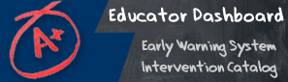

Quick Start Guide: Dashboard Administrator Navigation
Homepage
- Link to District homepage  - Site Configuration open  - Claim Sets  - Metric Settings  - Photo Management  - Interventions | 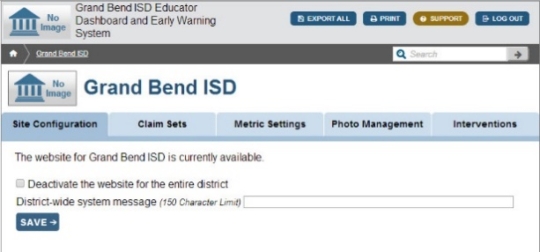
Site Configuration is where the Dashboard Administrator can Activate or deactivate the entire district dashboard site | 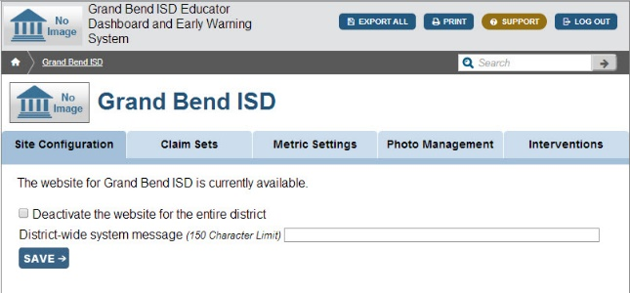
Claim Sets is where the Dashboard Administrator can edit claim sets singly or by batch | 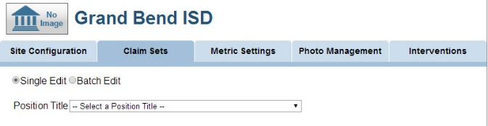
Metric Settings is where the Dashboard Administrator sets the Metric Threshold value for Course Grades below C Level | 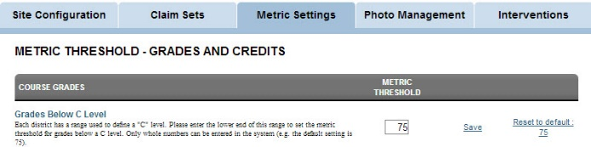
Photo Management is where the Dashboard Administrator imports student and staff photos to display on the dashboards | 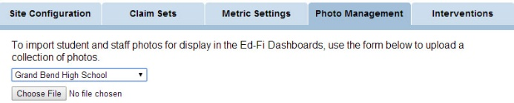
View School Level Dashboard  To view school level dashboards, use the School List tab under District Information | 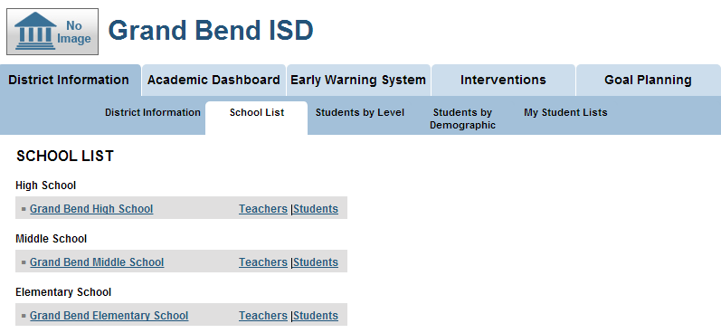
Viewing Interventions  To access the Intervention Catalog, click on the tab labeled “Interventions” | 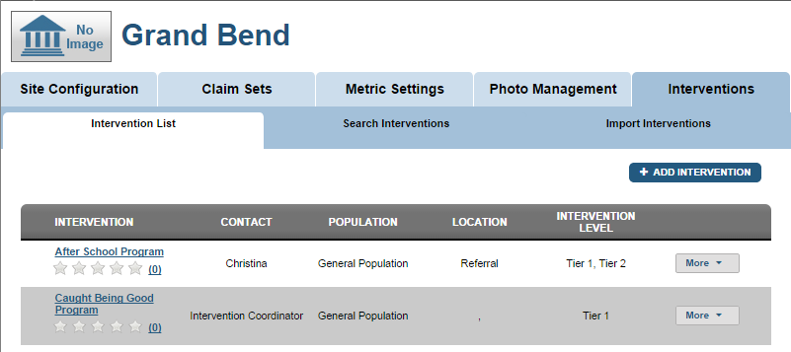
Add Intervention  - Go to the Interventions tab in the Dashboard  - Click Add Intervention | 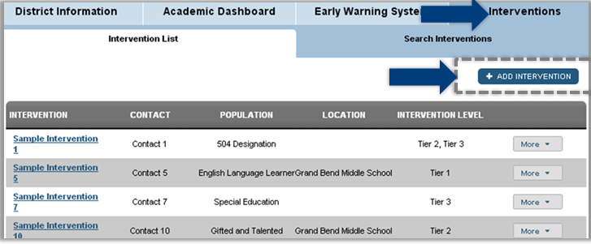
Edit Intervention  - Select the Intervention you wish to edit  - Select the More button from the menu  - Select Edit | 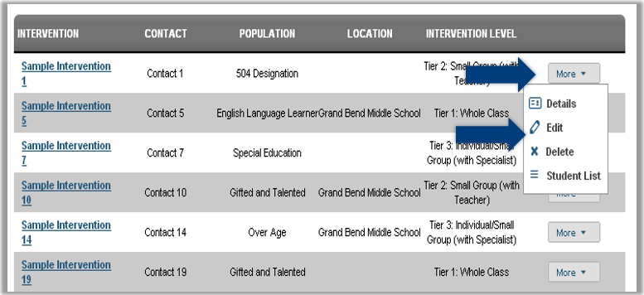
Delete Intervention  - Select the Intervention you wish to delete  - Select the More button from the menu  - Select Delete | 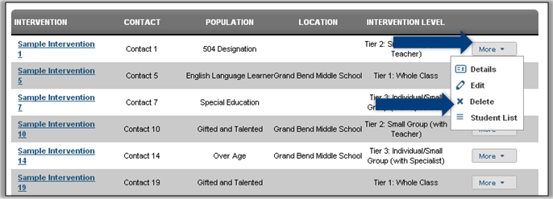
Goal Planning allows district administrators to set goals for each performance metric in the Dashboard at both the district and school levels. | 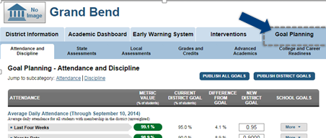
Setting New Goals  - Enter the new value in the New District Goal Column | 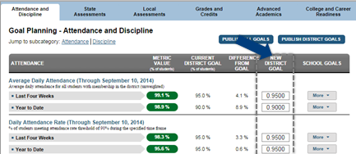
Publishing a New Goal  - Select Publish New District Goals | 