Pennsylvania Department of Education
Course 4B: Administrator Navigation
Quick Start Guide
Document #C4B.3

Quick Start Guide: Administrator Navigation
Logging In
To login to the dashboard for your district visit  http://www.education.state.pa.us  Click Log In if you are already registered with the portal. If you are not registered, please click on “Register” to create a new account | 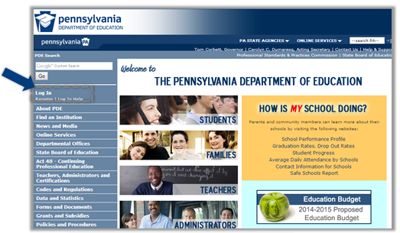
Enter your username and password | 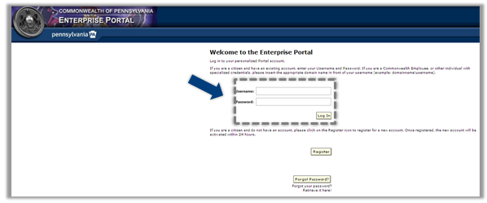
Click My PDE on the Left Blue Pane | 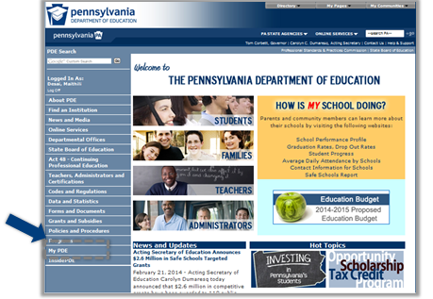
Under My PDE, click on Testing if you have NOT moved your dashboard data to production | 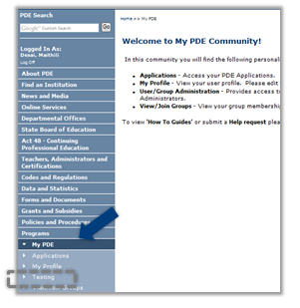
Click on Dashboard under Insider PDE, if you have moved your Dashboard data to Production | 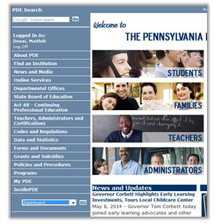
Under Applications, select “Dashboard”. If this is your first time logging in, you will need to enter your PPID, Date of Birth, and the last four digits of your SSN | 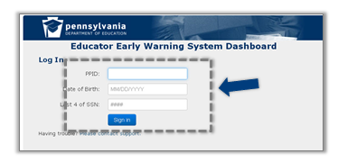
Navigation
Staff Homepage links available in the header:  1) Export all  2) Print  3) Support  4) Log Out  5) Link back to Home Page  6) Link to district information  7) Link to School Page | 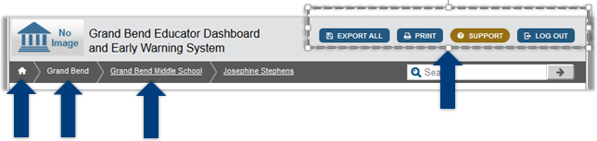
School Information - this slide shows the navigational tabs available on the school page. Data on the School level page is aggregated  - School information  - Academic dashboard  - Early warning system  - Interventions | 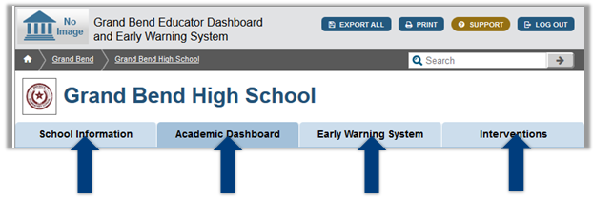
The legend of student indicators appears at the bottom of each screen on the dashboard | 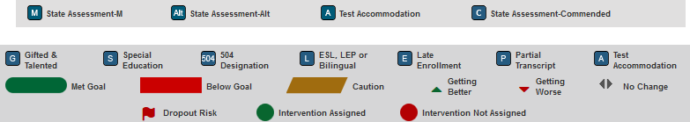
School Information  - Homepage for Administrators  - Administration  - Accountability  - Population by grade  - Population by Demographics | 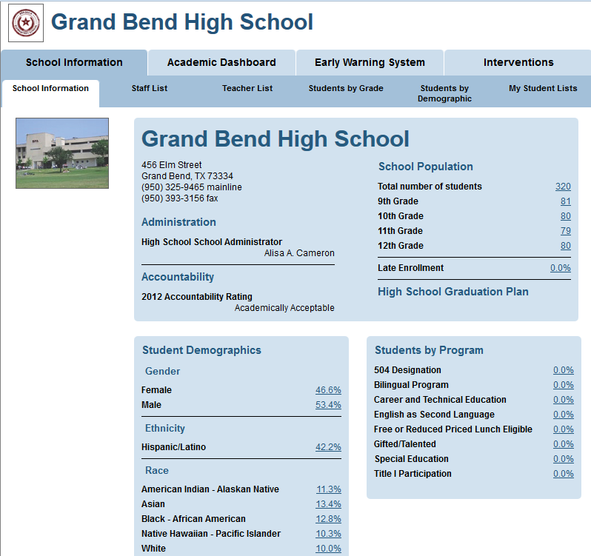
Academic Dashboard  - Accountability Rating for the school  - Overview  - Attendance and Discipline  - State and local assessments  - Grades and Credits  - Advanced Academics  College and Career Readiness | 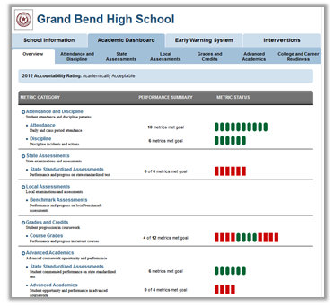
Early Warning System  - Failing Summary  - Percent Failing  Percent Caution | 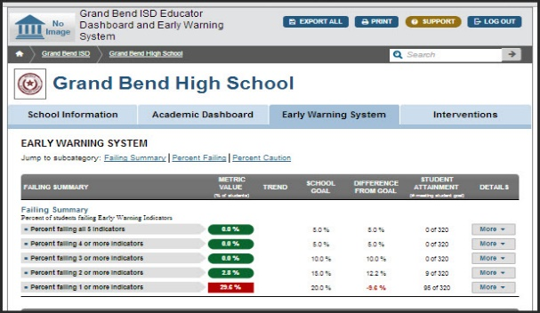
Interventions  - Search and assign from list of existing interventions | 