Pennsylvania Department of Education
Course 4A: Staff Navigation
Quick Start Guide
Document #C4A.4
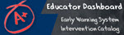

Quick Start Guide: Staff Navigation
Logging In
To log in to the dashboard for your district, visit http://www.education.state.pa.us  Click Log In if you are already registered with the portal. If you are not registered, please click on “Register” to create a new account | 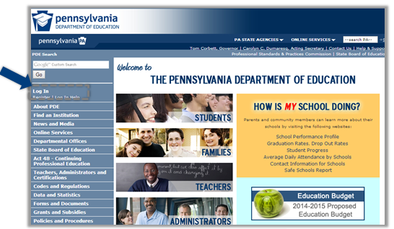
Enter your username and password | 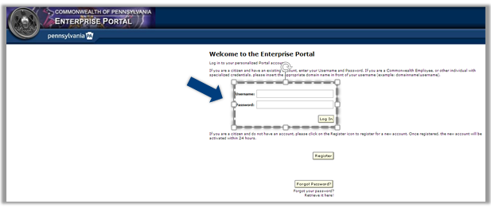
Click My PDE on the Left Blue Pane | 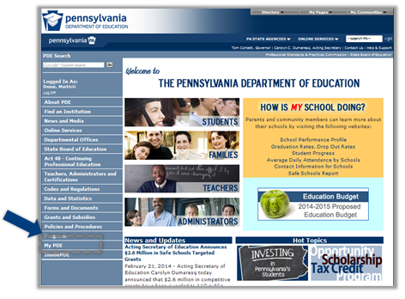
Under My PDE, click on Testing if you have NOT moved your dashboard data to production. | 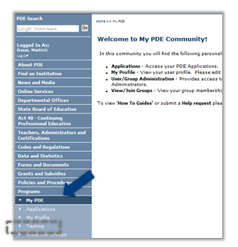
Click on Dashboard under Inside PDE if you have moved your dashboard data to production.
Under Applications, select “Dashboard”. If this is your first time logging in, you will need to enter your PPID, Date of Birth, and the last four digits of your SSN | 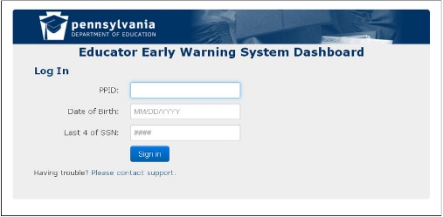

Navigation
Staff Homepage links available in the header:  1) Export all  2) Print  3) Support  4) Log Out  5) Link back to Home Page  6) Link to district information  7) Link to School Page | 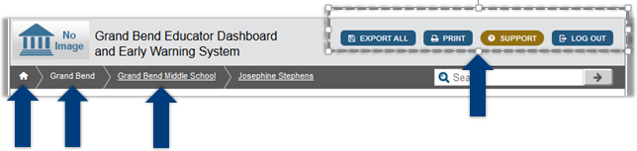
School Information - this slide shows the navigational tabs available on the school page. Data on the School level page is aggregated  - School information  - Academic dashboard  - Early warning system  - interventions | 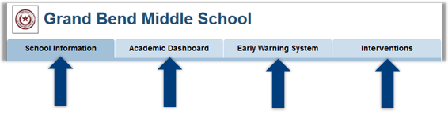
The legend of student indicators appears at the bottom of each screen on the dashboard | 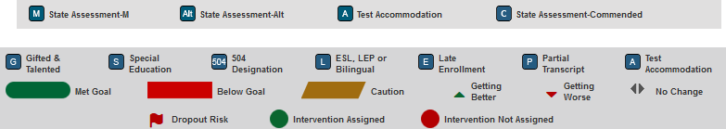
Staff Homepage Student List  Subject/Course/Section  Alphabetical by last name | 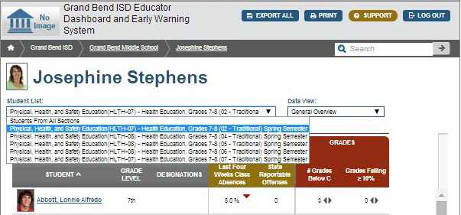
Academic Dashboard  The Academic Dashboard contains;  - Building level overview of Metrics  - Attendance and Discipline  - State and Local assessments  - Grades and Credits  - Advanced Academics  - College and Career Readiness | 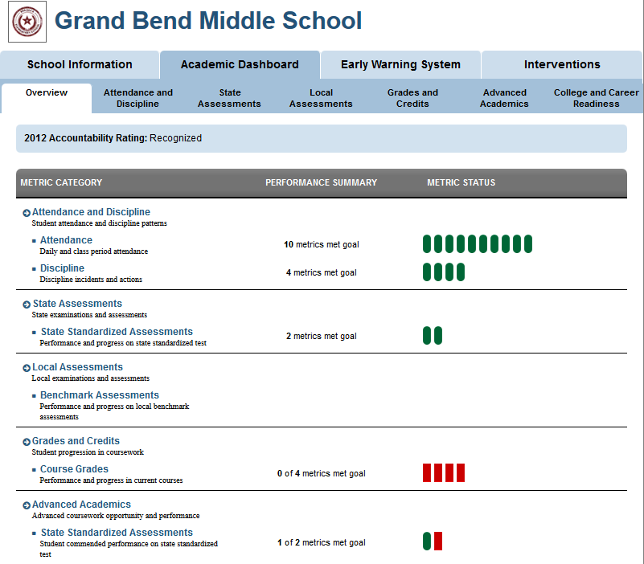
Student Information  These are the navigation tabs available to view student information.  - Student Overview  - Academic Dashboard  - Early Warning System  - Intervention Catalog  - Transcript | 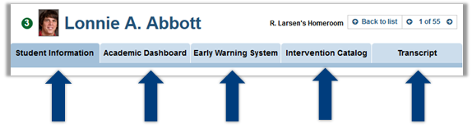
Student Interventions  The red (or green) circle at the top of student pages indicate if the student has interventions assigned.  The ref flag indicates the student is at risk of dropping out | 