Math News

March 2022
Educational Tech
Mentimeter is a polling tool that allows you to create interactive presentations and quizzes with real-time voting. The way it works is simple: use Mentimeter's online editor to create interactive slides that embed different question types including Multiple Choice, Word Cloud, Open ended, Scales, Ranking, and Q&A.

Instructional Resources
Computational Thinking - Research/Articles
Introduction to computational thinking
Tools for Integrating Computational Thinking and Mathematics in the Middle Grades
How-develop-computational-thinkers
Computational Thinking in PreK-5: Empirical Evidence for Integration and Future Directions
Cross Curricular
Engineering byDesign™ (EbD)™
A comprehensive, K-12 solution for Integrative Science, Technology, Engineering, and Mathematics (I-STEM).
Engineering byDesign™ (EbD)™ is built on the belief that the ingenuity of children is untapped, unrealized potential that, when properly motivated, will lead to the next generation of technologists, innovators, designers, and engineers.

PA Department of Education: PSSA and Keystone Assessment Windows
PSSA Testing Windows
Keystone Testing Windows

Professional Development Opportunities
SAS PD Center: Explore Professional Learning Opportunities
The SAS PD Center has several new offerings to support your professional growth. Courses are self-paced, are no cost, and provide Act 48 hours.

2022 PDE Data Summit
A New Beginning: Cultivating Safe and Equitable Systems for School Improvement
The Office of Child Development and Early Learning (OCDEL) is a unique office within the commonwealth as it is a dual deputate reporting to the Pennsylvania Departments of Education (PDE) and Human Services (DHS). OCDEL, through PDE, is offering an opportunity for school districts to engage in a continuous quality improvement process using certified observers / assessors and the CLASS assessment tool. The Classroom Assessment Scoring System ® (CLASS ®) is an observation instrument developed to assess classroom quality in Preschool through Third-Grade classrooms. https://teachstone.com/class/
CLASS not only defines teaching quality through the lens of interactions, but it also provides the ability to measure and improve the interactions that matter most for student outcomes. It’s a journey of continuous improvement that is data-driven and focused on what matters most for student outcomes, interactions. The tool is broken down into three distinct domains covering focused dimensions. Emotional Support looks at positive climate, negative climate, teacher sensitivity and regard for student perspective. Classroom Organization looks at behavior management, productivity, and instructional learning formats. Instructional Support covers concept development, quality feedback, and language modeling.
Observations consist of four 20-minute cycles lasting approximately two hours. Targeted feedback on areas of strength and areas of opportunity are provided to teachers and administrators within one week after the observation.
Click here to learn more! Contact Maryanne Olley at molley@pa.gov or Barry Wiestling at bwiestling@pa.gov for registration information.
Mathematics Coach Endorsement Program

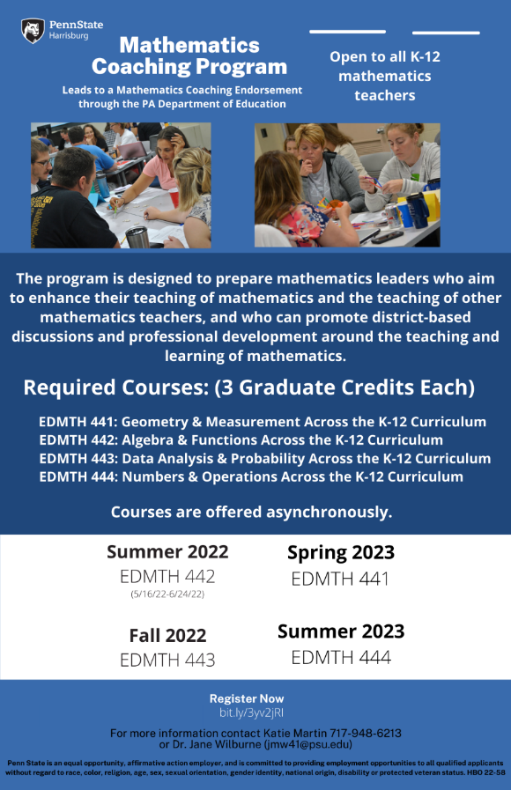

2022 Share My Lesson Virtual Conference (Mar. 21-22)
The 2022 Virtual Conference will showcase top-notch presenters who will provide valuable content to inspire your students and make them curious about topics ranging from civic education, social emotional learning, anti-racism, literacy, STEM, culturally responsive teaching and more. Register now to reserve your spot in sessions featuring presenters like: ADL, American Psychological Association, Barbara Blackburn, WETA’s Colorín Colorado, Girl Rising, Library of Congress, National Constitution Center, National Indian Education Association, NewsGuard, Next Gen Personal Finance, Random House, TeachRock and USC Shoah Foundation. This is a free event with over 50 webinars.

The Pennsylvania Commission on Crime and Delinquency (PCCD) announces the availability of $2,500,000 of state Violence and Delinquency Prevention Programs (VDPP) Funds.
Funding is available for nonprofit organizations, school districts, and other school entities to propose programming and other services to address youth mental health needs that have become apparent during the COVID-19 pandemic. A listing of possible approaches is included in the funding announcement, but PCCD is seeking innovative ways to assist our youth with difficulties they may have experienced as a result of the COVID-19 pandemic. Available funds are awarded through the Office of Justice Programs (OJP), Unit of Violence Prevention Initiatives, and will support the implementation of programs, best practices, policy improvements, and other approaches that will provide youth with improved supports for their mental health well-being. Support for Student Mental Health Needs PDF.

Content Advisor Contact Information
If you have any questions concerning Math News information; the Standards Aligned System (SAS); or want information regarding Curriculum, Instruction, or Assessment; please contact me at kmauro@pa.gov.

Kevin Mauro, Mathematics Curriculum Advisor

