Math News

August/September 2021

Teachers have worked extremely hard this past year, please consider nominating someone.
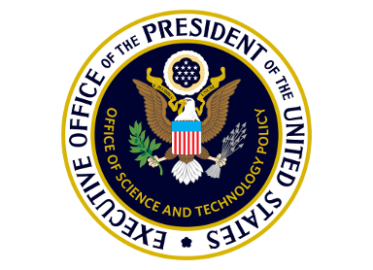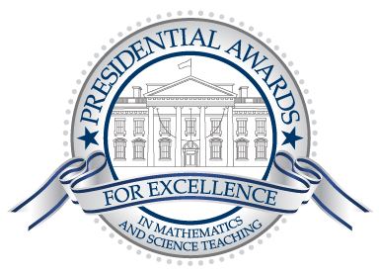
Presidential Awards for Excellence in Mathematics and Science Teaching
Rewarding & Inspiring Great Teaching Since 1983

Nominate outstanding K-6 science, technology, engineering, mathematics, and/or computer science teachers now for this award year.
PAEMST

This year's awards will honor science, technology, engineering, mathematics, and/or computer science teachers working in grades K-6. Nominations close January 7, 2022.
Nominate a Teacher

Applications for K-6th grade teachers are now open. Applications must be completed by February 6, 2022.
Begin an Application

National Teacher of the Year Program
The National Teacher of the Year Program began in 1952 and continues as the oldest, most prestigious national honors program that focuses public attention on excellence in teaching. Through this program, the Pennsylvania Department of Education identifies and honors K-12 teachers in public education who have made outstanding academic contributions to Pennsylvania's school-aged children.

TOY annually recognizes a professional who inspires students of all backgrounds and abilities to learn; who has the respect and admiration of students, parents, and colleagues; and who plays an active and useful role in both school and community.

Nominate a teacher whom you feel is worthy of consideration.

PA Department of Education

Resources for School Communities During COVID-19
Coronavirus (COVID-19) mitigation efforts have required school communities to work within changing, complex circumstances and unprecedented situations. The Pennsylvania Department of Education is committed to offering guidance and resources to support and help protect school communities during this pandemic.

Articles in Mathematics

WHAT WORKS IN MATH?

Evidence-Based Specially Designed Instruction in Mathematics – Resource Guide

Mathematician reveals world's oldest example of applied geometry

Instructional Resources

POWER Library Highlights
- E-Resources: E-Resources (subscription databases of articles, news, photographs, videos, DIY, etc.) will be particularly useful in lesson plans and for research resources. Access POWER Library E-Resources !
- Kids and Teens Sites: Sites designed for kids and teens are available at POWER Kids and POWER Teens !
- 24/7 Help: 24/7 live chat help! Text a Librarian and Email a librarian are available too.
- Single Sign-On: Remote access to POWER Library is available via Single Sign-On. Contact your school librarian or HSLC for more information.
- Lesson Plans! The POWER Library OER Hub, created to support PA educators is populated with lesson plans created specifically for POWER Library application; they are ready to download and remix. Visit the POWER Library OER Lesson Plans Hub !

To learn more, access POWER Library .

Working with the Pennsylvania Department of Education, the seven Pennsylvania Public Broadcasting System stations (Pennsylvania PBS) have created Learning at Home, a connection to thousands of hours of educational and entertaining videos, lesson plans, activities, and games to support teachers, students, and families.
PBS Toolkit on SAS
Pennsylvania PBS has curated free content aligned to state standards. PBS for Teachers
MathsBot is an excellent platform that offers a wide variety of educational resources for math teachers. These include GCSE resources, question generators, manipulatives, printables, puzzles, starters, games, activities and more. These materials are all free to use with your students. No registration or sign-up is required, MathsBot is completely web based.
The SAS Assessment Center has many new enhancements; you can build an assessment by searching the PDE database of standards-aligned items or creating your own assessment item utilizing the SAS step-by-step process. The check for understanding allows the user to send an assessment via URL to students to help support instruction.

Professional Development Opportunities
SAS PD Center: Explore Professional Learning Opportunities
The SAS PD Center has several new offerings to support your professional growth. Courses are self-paced, are no cost, and provide Act 48 hours.

AIU Math & Science Collaborative has been running since 2016. They have spent this past year designing an entirely virtual synchronous option and it has been very effective. All of the AIU MSC offerings are available fully virtual synchronous. Note (as is captured on the flyers) that both the K-2 and the 3-5 Institutes qualify as evidence-based strategies for mathematics on the PA Evidence Resource Center. This is particularly important for all CSI/ATSI Schools. All PD Institutes and courses can be found here: https://www.aiumsc.net//servicesnumbered

Professional Organizations
The Pennsylvania Council of Teachers of Mathematics (PCTM) is an affiliate of the National Council of Teachers of Mathematics (NCTM). The organization is made up of classroom teachers from pre-school to graduate school in addition to non-teachers who share an interest in mathematics education in the state of Pennsylvania.

Content Advisor Contact Information
If you have any questions concerning Math News information; the Standards Aligned System (SAS); or information regarding Curriculum, Instruction, or Assessment; please contact me at kmauro@pa.gov.
Kevin Mauro, Mathematics Curriculum Advisor

