Math News

December 2021

Teachers have worked extremely hard this past year. Consider submitting a nomination for the
Presidential Awards for Excellence in Mathematics and Science Teaching
Rewarding & Inspiring Great Teaching Since 1983

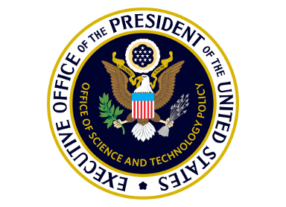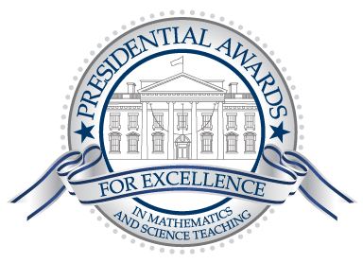

The Presidential Awards for Excellence in Mathematics and Science Teaching (PAEMST) recognizes outstanding K-6 science, technology, engineering, mathematics, and/or computer science teachers. This year's awards will honor science, technology, engineering, mathematics, and/or computer science teachers working in grades K-6. Nominations are open now and close January 7, 2022. All nominated teachers receive an email inviting them to begin the application process; applications must be completed by February 6, 2022.

Mathematics Education Podcasts
Are you a podcast listener? Or wanted to become one? Keep up with your professional learning by mixing one or more of these podcasts into your playlist. The Teaching Math Teaching Podcast is presented by the Association for Mathematics Teacher Educators and hosted by Joel Amidon, Dusty Jones, and Eva Thanheiser.
- Mathematics Teacher Educator Podcast - The Mathematics Teacher Educator Podcast is co-sponsored by the Association for Mathematics Teacher Educators and the National Council of Teachers of Mathematics and accompanies the Mathematics Teacher Educator Journal.
- Build Math Minds - Christina Tondevold hosts this weekly podcast from the perspective of a "recovering traditionalist."
- Kids Math Talk - This podcast from Desiree Harrison aims to give parents and educators practical tips and insights that deepen mathematical understanding while keeping a positive approach to learning math.

Educational Tech
What is Jamboard and How to use it in your teaching?
Google Jamboard is a collaborative whiteboard platform with huge educational potential. Since its introduction a few years ago, more and more teachers and educators are using it within educational contexts to augment teaching and learning. Google Jamboard leverages the power of collaborative whiteboarding in education making it super easy for individuals and teams to brainstorm, collaborate, and share ideas in real-time.

Instructional Resources
Math Fluency
Research/Articles
The Importance of Automaticity Development in Mathematics
Fluency: Simply Fast and Accurate? I Think Not!
Research shows the best ways to learn math
Math Fact Fluency Instruction – NWCommons
Effective Interventions to Improve Mathematic Fact Fluency
Cross Curricular
STEM Learning Ecosystems is a group of local cross-sector stakeholders that leverage collective action to produce high quality STEM experiences for every learner building knowledge and skills in preparation for a career. There are eight nationally recognized Ecosystems in Pennsylvania by the STEM Funders Network.

Center for Science and the Schools, CSATS is a leader in transforming precollege STEM education, contributing to the university’s land-grant mission in a 21st-century context by leveraging the research being done at Penn State. CSATS works with Penn State researchers and their colleagues to develop, implement, assess, and disseminate STEM outreach programs.

Professional Development Opportunities
SAS PD Center: Explore Professional Learning Opportunities
The SAS PD Center has several new offerings to support your professional growth. Courses are self-paced, are no cost, and provide Act 48 hours.
The Office of Child Development and Early Learning (OCDEL) is a unique office within the commonwealth as it is a dual deputate reporting to the Pennsylvania Departments of Education (PDE) and Human Services (DHS). OCDEL, through PDE, is offering an opportunity for school districts to engage in a continuous quality improvement process using certified observers / assessors and the CLASS assessment tool. The Classroom Assessment Scoring System ® (CLASS ®) is an observation instrument developed to assess classroom quality in Preschool through Third-Grade classrooms. https://teachstone.com/class/
CLASS not only defines teaching quality through the lens of interactions, but it also provides the ability to measure and improve the interactions that matter most for student outcomes. It’s a journey of continuous improvement that is data-driven and focused on what matters most for student outcomes, interactions. The tool is broken down into three distinct domains covering focused dimensions. Emotional Support looks at positive climate, negative climate, teacher sensitivity and regard for student perspective. Classroom Organization looks at behavior management, productivity, and instructional learning formats. Instructional Support covers concept development, quality feedback, and language modeling.
Observations consist of four twenty-minute cycles lasting approximately two hours. Targeted feedback on areas of strength and areas of opportunity are provided to teachers and administrators within one week after the observation.
Click here to learn more! Contact Maryanne Olley at molley@pa.gov or Barry Wiestling at bwiestling@pa.gov for registration information.

Shaping Authentic Practices by Engaging in Modeling of A Topic with Teachers to Explore Research in Science (SHAPE MATTERS) June 20 - July 2, 2022 Monday - Friday, 9 AM - 4 PM 118 Chambers Building, University Park, PA 16802 Deadline to apply: April 15, 2022
Professional Organizations
SHAPE MATTERS is a 10-day summer professional development workshop that will include in-person and virtual activities for Pennsylvanian secondary life science and chemistry teachers in collaboration with science education faculty from the Center for Science and the Schools (CSATS) and research scientists from the Penn State College of Medicine and the Eberly College of Science. Teachers will engage in techniques such as crystallization, structure determination, and modeling using the molecular visualization software, Jmol, to explore molecular stories related to human health. Teachers will work with the SHAPE MATTERS team to co-construct a molecular modeling research project for their classroom. The research project will support
student participation in the SMART teams program.
Participant Benefits:
- A $600 stipend for participating during the summer
- A $1,500 stipend for implementation of a molecular modeling research project
- in the classroom
- Over $2,000 of lab and molecular modeling materials for the classroom
- Invitation to bring students to present molecular modeling projects at the
- SMART teams symposium
- Act 48 credit is available upon request

Content Advisor Contact Information
If you have any questions concerning Math News information; the Standards Aligned System (SAS); or want information regarding Curriculum, Instruction, or Assessment; please contact me at kmauro@pa.gov.

Kevin Mauro, Mathematics Curriculum Advisor

