Math News

November 2021

Teachers have worked extremely hard this past year. Consider submitting a nomination for the
Presidential Awards for Excellence in Mathematics and Science Teaching
Rewarding & Inspiring Great Teaching Since 1983

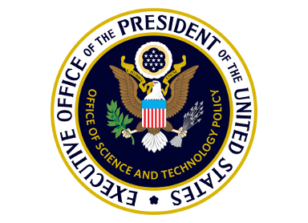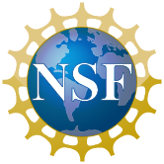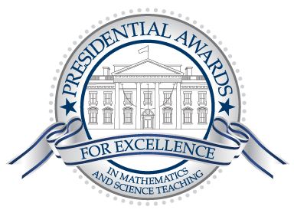

The Presidential Awards for Excellence in Mathematics and Science Teaching (PAEMST) recognizes outstanding K-6 science, technology, engineering, mathematics, and/or computer science teachers. This year's awards will honor science, technology, engineering, mathematics, and/or computer science teachers working in grades K-6. Nominations are open now and close January 7, 2022. All nominated teachers receive an email inviting them to begin the application process; applications must be completed by February 6, 2022.

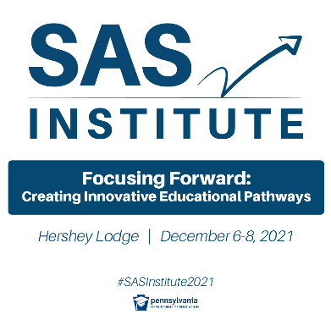
Are You Ready to Focus Forward? Join Us at the SAS Institute!
This year's SAS Institute, Focusing Forward: Creating Innovative Educational Pathways, scheduled for December 6-8, 2021, at the Hershey Lodge and Convention Center (virtual option also available) will center around five major strands designed to transform learning:
- Pathways to Quality Instruction
- Pathways to a Healthy Learning Environment
- Pathways to Prepare for the Future
- Pathways to Continuous School Improvement
- Pathways for Accelerating Learning

Each day will begin with a dynamic keynote speaker, followed by breakout sessions presented primarily by PA educators and PA Department of Education staff.
View Featured Content

PA Department of Education

Resources for School Communities During COVID-19
Coronavirus (COVID-19) mitigation efforts have required school communities to work within changing, complex circumstances and unprecedented situations. The Department is committed to offering guidance and resources to support and help protect school communities during this pandemic.
Mathematics Education Podcasts
Are you a podcast listener? Or wanted to become one? Keep up with your professional learning by mixing one or more of these podcasts into your playlist. The following are just some of the podcasts active in mid-2021 that focus on teaching, research, and other issues in mathematics education.
- Math Ed Podcast - Samuel Otten of the University of Missouri has hosted more than 100 episodes of the Math Ed Podcast since 2012.
- Learning With Leaders - NCSM, the national mathematics leadership organization, hosts a monthly podcast featuring conversations with emerging and established math education leaders.
- Teaching Math Teaching Podcast - The Teaching Math Teaching Podcast is a podcast by the Association for Mathematics Teacher Educators hosted by Joel Amidon, Dusty Jones, and Eva Thanheiser.
- Mathematics Teacher Educator Podcast - The Mathematics Teacher Educator Podcast is co-sponsored by the Association for Mathematics Teacher Educators and the National Council of Teachers of Mathematics and accompanies the Mathematics Teacher Educator Journal.
- Build Math Minds - Christina Tondevold hosts this weekly podcast from the perspective of a "recovering traditionalist."
- Kids Math Talk - This podcast from Desiree Harrison aims to give parents and educators practical tips and insights that deepen mathematical understanding while keeping a positive approach to learning math.
- Learning Through Math - Hosts Laura Tomas and Karina Cousins, a math coach and a fifth grade teacher in Palm Beach County, Florida, have hosted Learning Through Math since 2020 and publish episodes about math teaching topics almost every week.
- Making Math Moments that Matter - Kyle Pearce and Jon Orr discuss ways to build better mathematics classrooms that kids want to be part of. Together, they've been hosting the podcast since 2018.
- Math Before Breakfast - Math Before Breakfast is hosted by Tracy Profitt, an instructional coach, and Ruth Erquiaga, a 6th grade math teacher. They've been publishing episodes about every other week since 2018.
- Math is Figure-Out-Able - Pam Harris and her co-host Kim Montague try to answer the question "If not algorithms, then what?" in this weekly podcast.
- Room to Grow - A Math Podcast - Joanie Funderburk and Curtis Brown publish this new podcast every other week and discuss trending topics in math education.

Instructional Resources
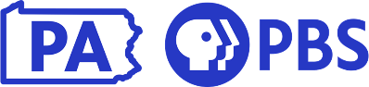
Working with the Pennsylvania Department of Education, the seven Pennsylvania Public Broadcasting System stations (Pennsylvania PBS) have created Learning at Home, a connection to thousands of hours of educational and entertaining videos, lesson plans, activities, and games to support teachers, students, and families.
PBS Toolkit on SAS
Pennsylvania PBS has curated free content aligned to state standards. Go to PBS for Teachers
Educational Technology and Mobile Learning offers access to a wide variety of printable math worksheets to use in your class to help students with their math learning. Some of these sites also offer other math learning materials, including interactive games, puzzles, activities, tools, and many more. Most of the worksheets you will find in these sites come in pdf form and sometimes in html files as well.
The SAS Assessment Center has many new enhancements: you can build an assessment by searching the PDE database of standards-aligned items or create your own assessment items utilizing the SAS step-by-step process. The check for understanding allows the user to send an assessment via URL to students to help support instruction.
Cross Curricular
STEM Learning Ecosystems is a group of local cross-sector stakeholders that leverage collective action to produce high quality STEM experiences for every learner building knowledge and skills in preparation for a career. There are eight nationally recognized Ecosystems in Pennsylvania by the STEM Funders Network.

Professional Development Opportunities
SAS PD Center: Explore Professional Learning Opportunities
The SAS PD Center has several new offerings to support your professional growth. Courses are self-paced, are no cost, and provide Act 48 hours.

Professional Organizations
The Pennsylvania Council of Teachers of Mathematics (PCTM) is an affiliate of the National Council of Teachers of Mathematics (NCTM). The organization is made up of classroom teachers from pre-school to graduate school in addition to non-teachers who share an interest in mathematics education in the state of Pennsylvania.

Content Advisor Contact Information
If you have any questions concerning Math News information; the Standards Aligned System (SAS); or want information regarding Curriculum, Instruction, or Assessment; please contact me at kmauro@pa.gov.

Kevin Mauro, Mathematics Curriculum Advisor

