FACILITATOR Module 1 DESIGN

To meet the following objectives, participants will use a pre-existing assessment or create a new assessment

Participants will be able to:
1. Create an assessment’s purpose statement.
2. Identify targeted content to be measured.
3. Develop specification tables that create an assessment’s blueprint.

Group Work: Participants are to complete the following independently.
Depth of Knowledge Pretest
Purpose: This will serve as a formative assessment of participants in the Assessment Literacy Course. Results of the assessment will be used to create a guide for instruction and content in the course. This will facilitate educator achievement in increasing rigor, reliability, and validity of assessments offered in each grade level.

Depth of Knowledge (DOK) Level Pretest
Purpose: This will serve as a formative assessment of participants in the Assessment Literacy Course. Results of the assessment will be used to create a guide for instruction and content in the Assessment Literacy course. This will facilitate educator achievement in increasing rigor, reliability, and validity of assessments offered in each grade level.

Directions: Based on your understanding of Depth of Knowledge, assign the appropriate level to the following assessment questions.
Webb’s Depth of Knowledge

Level 1: Recall and Reproduction Level 3: Strategic Thinking
Level 2: Skills and Concepts Level 4: Extended Thinking

DOK
1 | 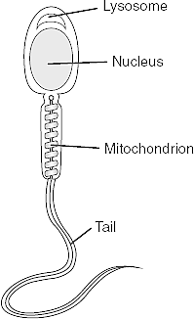  1. Which structure stores most of the genetic information?  A. mitochondrion  B. lysosome  C. nucleus  D. tail
1  Or  2 | 2. “People were running toward him like iron filings to a magnet.”  The author uses this simile to emphasize that the people  A. were interested in the news about the gold  B. were curious about the hip’s arrival  C. wanted to become gold prospectors  D. were unable to resist reading about the gold
1 | 3. Which of the following is the best definition of seismograph?  A. an apparatus for measuring sound waves  B. an apparatus for measuring heat waves  C. an apparatus for measuring earthquake waves  D. An apparatus for measuring ocean waves
3 | 4. As an officer in the British Army in the 1750’s, use the map of the Ohio country mark where you would locate trading posts /forts to gain strategic control of the area for trade and defense. Provide a short explanation of your reasoning in the space below.  (Not to scale)  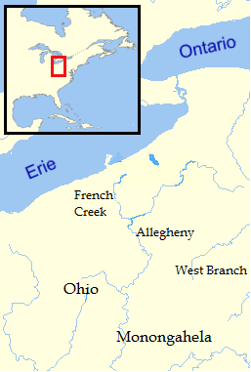
2 | 5 Kelly is chairperson on the cheerleader bake sale to raise funds for new uniforms which are $200 a piece for the 8 member squad. She has practice until 5 P.M. every night. She has Chemistry Lab 3 hours and 15 before she goes home. She had lunch 2 hours and 10 minutes before her Lab class. Lunch is the only time she has to meet with the members of the bake sale committee. What time should be on her e-vite to have the committee members meet her for lunch?  A. 10:25 PM  B. 10:25 AM  C. 11:35 PM  D. 11:35 AM
1 | 6. Based on the entire passage, what is the meaning of the word “momentous” in line 18?  A. Causes much happiness  B. Creates a great disturbance  C. Occurs simply by chance  D. B and C
2 | 7. Sergei Prokofiev was commissioned to write a musical symphony for children. Each character in the story has a particular instrument and a musical theme to tell the story. Walt Disney produced an animated version of the work in 1946 with Sterling Holloway providing the voice of the narrator. This children’s classic is known as: ___________________.  A. Austin Powers Gold Member  B. Peter and the Wolf  C. Bugs Bunny 1001 Rabbit Tales  D. Sleeping Beauty
3  or  4 | 8. Evaluate the nutritional needs of a family of three with two adults and a preschool child. Choose recipes for a full day of meals and snacks to meet these needs. Please justify the menu choices, explaining the ways in which these choices are nutritionally sound and meet the daily requirements of nutritional needs by using the provided food pyramid.  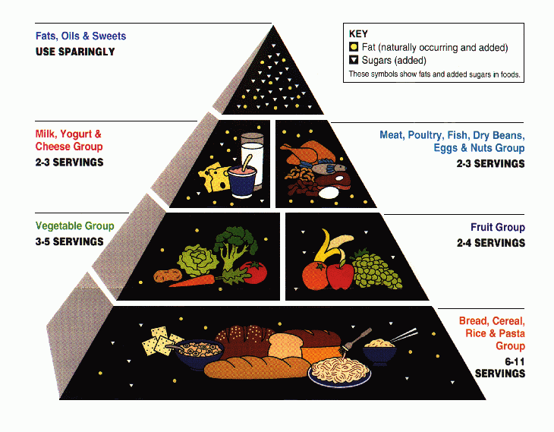
1 | 9. In what year did the United States enter World War 1?  A. 1776  B. 1865  C. 1917  D. 1941
1 | 10. Which of the following cell types is formed by meiosis?  A. muscle cells  B. sperm cells  C. skin cells  D. blood cells

SLIDES 5-6

Level 1: Recall and Reproduction
Tasks at this level require recall of facts or rote application of simple procedures. The task does not require any cognitive effort beyond remembering the right response or formula. Copying, computing, defining, and recognizing are typical Level 1 tasks.

Level 2: Skills and Concepts
At this level, a student must make some decisions about his or her approach. Tasks with more than one mental step such as comparing, organizing, summarizing, predicting, and estimating are usually Level 2.

Level 3: Strategic Thinking
At this level of complexity, students must use planning and evidence, and thinking is more abstract. A task with multiple valid responses where students must justify their choices would be Level 3. Examples include solving non-routine problems, designing an experiment, or analyzing characteristics of a genre.

Level 4: Extended Thinking
Level 4 tasks require the most complex cognitive effort. Students synthesize information from multiple sources, often over an extended period of time, or transfer knowledge from one domain to solve problems in another. Designing a survey and interpreting the results, analyzing multiple texts by to extract themes, or writing an original myth in an ancient style would all be examples of Level 4

SLIDE 10
- What is the ultimate purpose of the assessment?
- What is it that needs to be measured?
  - Academic Standards
- Depth of knowledge
- Time allotment
- Diverse opportunities for demonstration of knowledge

SLIDES 11- 14 Purpose Statements

The primary purpose of assessment is to improve students' learning and teachers' teaching as both respond to the information it provides.

Assessment for learning is an ongoing process that arises out of the interaction between teaching and learning.

An assessment’s purpose statement outlines why the assessment was developed, what the assessment is measuring, and how the results (scores) can be used.

The purpose statement can be brief and help guide the assessment creator to stay focused on what items need to be on the test.

SLIDE 15 - 17 Purpose Statement Examples

- The Grade 8 Pre-Algebra assessment is provided as a post-test to determine student mastery of the content standards.
- This grade-level summative assessment is intended to measure student proficiency of grade-level expectations in the sequence of the district’s algebra curriculum.
- Scores represent degrees of content knowledge, and are used as part of pupil progression for 8th grade students.
- This assessment will evaluate student content acquisition and mastery of ________ to determine progression of unit scope and sequence.
- Assessment results are to determine mastery of vocabulary for learning Science concept 3.1.4.A1. Describe the similarities and differences of physical characteristics in plants and animals and Language Art Standard CC.1.2.4.F Determine the meaning of words and phrases as they are used in grade-level text, including figurative language.
- Scores will represent student understanding of the concept growth and development over time.
- This test is to create a record of student knowledge prior to instruction on drug and alcohol use on the human body.
- Assessment scores will be used to determine student mastery of the concept ______________.

Purpose Statement
SLIDE 18 Group Work: “Creating a Purpose Statement”
Participants will use a pre-existing assessment or create a new assessment.
Purpose statement:

SLIDE 19
An assessment’s targeted content is found in the district curriculum.
Select:
- Big idea/enduring understanding statements within the content area.
- Essential questions
- The essential knowledge and skills for which students are expected to demonstrate achievement.

Module 1.2 Targeted Content

SLIDES 20-21
An assessment’s targeted content standards are those standards that will be assessed.

Group Work : “Identifying content”
Participants will use a pre-existing assessment or create a new assessment

Write a simple statement of what standard or concept (Big ideas, essential questions)
the assessment measures.

Module 1.3 Blueprints

SLIDE 24

- Number and types of items on the final assessment;
- Content, skills, and any other attribute to be measured;
- Intended level of difficulty; DOK
- Mode of administration
- Timing of the total administration/separate sections or subparts
- Directions for examinees.

SLIDE 25 Terms you will need to know to keep going.

SR-Selected Response: items that are multiple choice, true-false, matching, any item where the test-taker has a bank of answers from which they choose an answer.

SCR-Short Constructed Response/Short Answer: the test-taker provides a one word or short phrase answer

ECR-Extended Constructed Response: the test-taker writes a paragraph or two, or develops an authentic response within a class period’s time length

PT- Performance Task: the test-taker develops a response that takes several class periods or the response is gathered over a period of time, as in a portfolio assessment.

SLIDE 27- “Developing A Blueprint”
Using the 10 question assessment that was just used in the last group work task,
create a blueprint for that assessment.

Group Work - 2. Build Item Type Pretest

2. Build- Item Type Pretest
Purpose: This will serve as a formative assessment of participants in the Assessment Literacy Course. Results of the assessment will be used to create a guide for instruction and content in the course. This will facilitate educator achievement in increasing rigor, reliability, and validity of assessments offered in each grade level.

Directions: Based on your knowledge of item types, assign the appropriate type to the following questions.
Selected Response (SR), where answer options are provided to the test-taker,
Short Constructed Response (SCR), where the answer is created by the test-taker,
Extended Constructed Response (ECR), where a complex answer is created by the test-taker, and
Performance Tasks (PT), where answers created by the test taker are used to create additional responses by the test-taker.

SR | 1. Which structure stores most of the genetic information?  A. mitochondrion  B. lysosome  C. nucleus  D. tail
SR | 2. “People were running toward him like iron filings to a magnet.”  The author uses this simile to emphasize that the people  A. were interested in the news about the gold  B. were curious about the hip’s arrival  C. wanted to become gold prospectors  D. were unable to resist reading about the gold
SR | 3. Which of the following is the best definition of seismograph?  A. an apparatus for measuring sound waves  B. an apparatus for measuring heat waves  C. an apparatus for measuring earthquake waves  D. An apparatus for measuring ocean waves
SCR | 4. As an officer in the British Army in the 1750’s, use the map of the Ohio country mark where you would locate trading posts /forts to gain strategic control of the area for trade and defense. Provide a short explanation of your reasoning in the space below.  (Not to scale)
SR | 5 Kelly is chairperson on the cheerleader bake sale to raise funds for new uniforms which are $200 a piece for the 8 member squad. She has practice until 5 P.M. every night. She has Chemistry Lab 3 hours and 15 before she goes home. She had lunch 2 hours and 10 minutes before her Lab class. Lunch is the only time she has to meet with the members of the bake sale committee. What time should be on her e-vite to have the committee members meet her for lunch?  A. 10:25 PM  B. 10:25 AM  C. 11:35 PM  D. 11:35 AM
SR | 6. Based on the entire passage, what is the meaning of the word “momentous” in line 18?  A. Causes much happiness  B. Creates a great disturbance  C. Occurs simply by chance  D. B and C
SR | 7. Sergei Prokofiev was commissioned to write a musical symphony for children. Each character in the story has a particular instrument and a musical theme to tell the story. Walt Disney produced an animated version of the work in 1946 with Sterling Holloway providing the voice of the narrator. This children’s classic is known as: ___________________.  A. Austin Powers Gold Member  B. Peter and the Wolf  C. Bugs Bunny 1001 Rabbit Tales  D. Sleeping Beauty
ECR  PT | 8. Evaluate the nutritional needs of a family of three with two adults and a preschool child. Choose recipes for a full day of meals and snacks to meet these needs. Please justify the menu choices, explaining the ways in which these choices are nutritionally sound and meet the daily requirements of nutritional needs by using the provided food pyramid.
SR | 9. In what year did the United States enter World War 1?  A. 1776  B. 1865  C. 1917  D. 1941
SR | 10. Which of the following cell types is formed by meiosis?  A. muscle cells  B. sperm cells  C. skin cells  D. blood cells

SLIDE 29 Create a Blueprint
Blueprints can be simple or very formal.
Does not matter the format, just make one.
This will assist in providing the variety of questions and depth of knowledge range in the assessment.

SLIDE 30 Quality Control Checklist
- Number and types of items on the final assessment
- Content, skills, and any other attribute to be measured;
- Intended level of difficulty; DOK
- Mode of administration
- Timing of the total administration/separate sections or subparts
- Directions for examinees.

SLIDE 31 and 32 Group Work- “Developing A Blueprint”
Using the 10 question assessment that was just used in the last group work task, create a blueprint for that assessment.
Assessment Title: ______________________________ Department: ______________________
Grade level: ____
Assessment Purpose:

Item/  Scoring Criteria | Item/Criteria Type |  |  |  |  |  |  |  | DOK
 | SR | Points | SCR | Points | ECR | Points | EP | Points | DoK 1 | DoK 2 | DoK 3 | DoK 4
totals

