Pennsylvania Department of Education
Assessment Literacy

Anticipation Guide—Module 1: Assessment Design

Use the following Anticipation Guide to preview your current knowledge about designing assessments. Before you begin Module 1, mark whether or not you agree or disagree with each statement. After completing Module 1, fill in the slide number where you found information to support learning of the statement, tell whether or not you were right, and reflect on what you found.

Statements | Agree/ Disagree | Slide # | Were you right? | Reflection
1. The construct for which a teacher would design an assessment is student achievement of content standards.
2. An assessment’s validity is based on the amount of information included in the assessment.
3. Teacher-built assessments can only be used for the purpose of providing report card grades.
4. Building consensus among teachers of common grade or content on an assessment’s purpose, targeted content standards and specification tables is an optional step in the assessment design process.
5. Assessments should assess all standards that are taught.
6. Specification tables determine how individual test items and tasks are written.
7. The relationship between an assessment’s specification tables and its alignment characteristics creates relevance, subsequently creating validity.

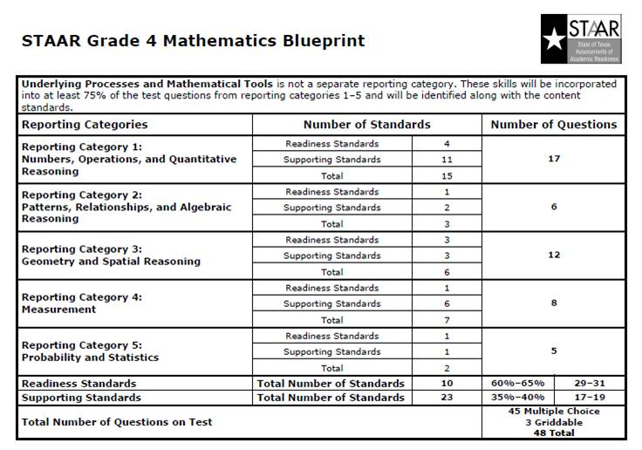

Process for Creating a Purpose Statement

Slide | Prompt | Response
12 | Select a test or project that you administer in your content area.
12 | What is the purpose of this test/project?
14 | Why did you develop (or select) this test or project?
14 | Do the questions/tasks and/or scoring rubrics relate specifically to a content standard?  (Convergent and discriminant validity)
15 | What is this test or project measuring?  Do the questions/tasks measure student performance in relation to a pre-defined performance level?  (Test-criterion validity)
16 | How will the student scores be used—report card grade, promotion, job placement, etc.)  (Consequential validity)

Grade 7 ELA Midterm

Fill in the “Selecting Targeted Standards” grid as preparation for designing a one-hour 7th grade mid-year exam based on:

Purpose Statement: The 7th Grade Midterm ELA Exam is intended to measure student mastery of PA Core Standard 1.2, Reading Informational Text. This grade-level summative assessment is intended to measure mid-year proficiency of the standard for all district 7th grade students, based on expected grade-level proficiency as defined by state standardized testing protocols. Scores will be used as part of the student’s second marking period grade report and test item response will be analyzed by the district for diagnostic purposes at both the individual remedial and curriculum adjustment levels.

PA Core Standard 1.2 Reading Informational Text
Students read, understand, and respond to informational text—with an emphasis on comprehension, vocabulary acquisition, and making connections among ideas and between texts with focus on textual evidence.

Big Idea: Align the Standard Statement with the Big Ideas (found on PM 7) A through H.

Endurance: Consider if this standard will provide 7th graders with knowledge and skills that will be of value beyond a single test date.
Rate the Standard as (H) High Endurance
(M) Medium Endurance
(L) Low Endurance

Leverage: Consider if this standard provides 7th graders with knowledge and skills that will be of value in multiple disciplines.
Rate the Standard as (H) High Endurance
(M) Medium Endurance
(L) Low Endurance

Readiness for Next Level of Learning: Consider if this standard provides students with essential knowledge and skills necessary for success in the next level of learning.
Rate the Standard as (H) High Endurance
(M) Medium Endurance
(L) Low Endurance

SELECTING TARGETED STANDARDS GRID
Big Idea | Endurance | Leverage | Readiness | Standard Statement
CC.1.2.7.A
Determine two or more central ideas in a text and analyze their development over the course of the text; provide an objective summary of the text.
E07.B-K.1.1.2
CC.1.2.7.B
Cite several pieces of textual evidence to support analysis of what the text says explicitly, as well as inferences, conclusions, and/or generalizations drawn from the text.
E07.B-K.1.1.1
CC.1.2.7.C
Analyze the interactions between individuals, events, and ideas in a text.
E07.B-K.1.1.3
CC.1.2.7.D
Determine an author’s point of view or purpose in a text and analyze how the author distinguishes his or her position from that of others.
E07.B-C.2.1.1
CC.1.2.7.E
Analyze the structure of the text through evaluation of the author’s use of graphics, charts,
and the major sections of the text.
E07.B-C.2.1.2
CC.1.2.7.F
Determine the meaning of words and phrases as they are used in grade-level reading and content, including interpretation of figurative, connotative, and technical meanings.
E07.B-V.4.1.1, E07.B-V.4.1.2, E07.B-C.2.1.3
CC.1.2.7.G
Compare and contrast a text to an audio, video, or multimedia version of the text, analyzing each medium’s portrayal of the subject (e.g., how the delivery of a speech affects the impact of the words).
CC.1.2.7.H
Evaluate an author’s argument, reasoning, and specific claims for the soundness of the argument and the relevance of the evidence.
E07.B-C.3.1.1
CC.1.2.7.I
Analyze how two or more authors present and interpret facts on the same topic.
E07.B-C.3.1.2
CC.1.2.7.J
Acquire and use accurately grade-appropriate general academic and domain-specific words and phrases; gather vocabulary knowledge when considering a word or phrase important to comprehension or expression.
E07.B-V.4.1.1, E07.B-V.4.1.2
CC.1.2.7.K
Determine or clarify the meaning of unknown and multiple-meaning words and phrases based on grade-level reading and content, choosing flexibly from a range of strategies and tools.
E07.B-V.4.1.1
CC.1.2.7.L
Read and comprehend literary nonfiction and informational text on grade level, reading independently and proficiently.

PA Core Aligned ELA Curriculum Framework

English Language Arts

Long Term Transfer Goals

Transfer goals highlight the effective uses of understanding, knowledge, and skill that we seek in the long run; i.e., what we want students to be able to do when they confront new challenges – both in and outside of school.
Students will be able to independently use their learning to:

1. Comprehend and evaluate complex texts across a range of types and disciplines.
2. Be a critical consumer of text and other media to recognize, understand, and appreciate multiple perspectives and cultures
3. Produce writing to address task, purpose, perspective, and intended audience; research and gather evidence to create a clear and coherent message
4. Communicate effectively for varied purposes and audiences.
5. Listen actively to engage in a range of conversations, to analyze and synthesize idea and positions, and to evaluate accuracy in order to learn, reflect, and respond.
Big Ideas | Essential Questions
A. Effective readers use appropriate strategies to construct meaning. | How do strategic readers create meaning from informational and literary text?  What is this text really about?  How do readers know what to believe?  How do what readers read influence how they should read it?  How does a reader’s purpose influence how text should be read?
B. Critical thinkers actively and skillfully interpret, analyze, evaluate, and synthesize information. | How do readers know what to believe in what they read, hear, and view?  How does interaction with text provoke thinking and response?
C. Active listeners make meaning from what they hear by questioning, reflecting, responding, and evaluating. | What do good listeners do?  How do active listeners make meaning?  How do active listeners know what to believe in what they hear?
D. Effective speakers prepare and communicate messages to address the audience and purpose. | How do task, purpose, and audience influence how speakers craft and deliver a message?  How do speakers employ language and utilize resources to effectively communicate a message?
E. Effective research requires the use of varied resources to gain or expand knowledge. | What does a reader look for and how can s/he find it?  How does a reader know a source can be trusted?  How does one organize and synthesize information from various sources?  How does one best present findings?
F. Audience and purpose influence a writer’s choice of organizational pattern, language, and literary techniques. | What makes clear and effective writing?  Why do writers write? What is the purpose?  Who is the audience? What will work best for the audience?
G. Rules of grammar and language conventions support clarity of communications between writers/speakers and readers/listeners. | How do learners make decisions concerning formal and informal language in social and academic settings?  How do grammar and the conventions of language influence spoken and written communication?
H. An expanded vocabulary enhances one’s ability to express ideas and information. | Why learn new words?  What strategies and resources does the learner use to figure out unknown vocabulary?  How does one develop and refine vocabulary?

Developing Specification Tables

Based on the Big Idea selected for measuring 7th Grade student achievement of PA Core Standard 1.2, Reading Informational Text, complete the following “Training” specification table for two standards within the identified Big Idea. Remember, the assessment should not take more than one hour for students to complete.

A “Training” Specification Table

Big Idea/  Enduring Understanding | Standard  ID | Item Types
 |  | SR |  | SCR |  | ECR |  | PT | Total
 |  | Points Per Item/Total Points
 |  | Depth of Knowledge
 |  | DoK 1 |  | DoK 2 |  | DoK 3 |  | Dok 4
 |  | Reading Levels
 |  | Passage Genre |  |  |  |  | Writing
 |  | Reading Level | Literature |  | Information |  | Prompt Response
 |  |  | 0
 | Standard  ID | Item Types
 |  | SR |  | SCR |  | ECR |  | PT | Total
 |  | Points Per Item/Total Points
 |  | Depth of Knowledge
 |  | DoK 1 |  | DoK 2 |  | DoK 3 |  | Dok 4
 |  | Reading Levels
 |  | Passage Genre |  |  |  |  | Writing
 |  | Reading Level | Literature |  | Information |  | Prompt Response
 |  |  | 0
 |  |  | 0
- Reading Level: The level at which both word identification and comprehension fall within the expected developmental age/grade of the test-taker.
- Prompt Response: Opinion, Argumentative, Informational, Expository

The Relationship between Alignment Characteristics and Design Concepts

Link the alignment characteristic to any design concepts affected by that characteristic. Count the number of relationships in both directions. Place the number in the circles.
Alignment Characteristics Design Concepts

4. Item/Task Sufficiency

3. Content Pattern
1. Content Match
2. Cognitive Demand/DoK

n. Operational Form Construction
m. Item Construction
l. Purpose Statement
k. Validity
j. Number of Items
i. Targeted Standards
h. Reading Level
g. Depth of Knowledge
f. Performance Task
e. Extended Constructed Response Item
d. Short Constructed Response Item
c. Selected Response Item
b. Standard ID
a. Big Idea/Enduring Understanding

