Pennsylvania Department of Education
Course 4C: Intervention Coordinator Navigation
Quick Start Guide
Document #C4C.3
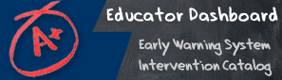

Quick Start Guide: Intervention Catalog Coordinator
Intervention Catalog
Viewing Interventions  To access the Intervention Catalog, click on the tab labeled “Interventions”  View interventions by clicking on the Interventions List tab | 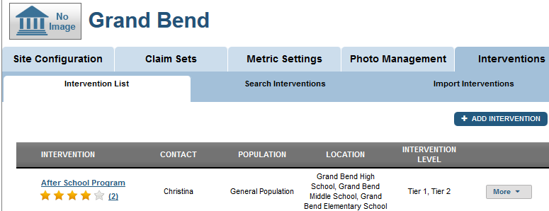
Assigning Interventions:  To assign an intervention to a student:  - Click on s student name to access student data  - Search for an intervention on that student’s Intervention Catalog page | 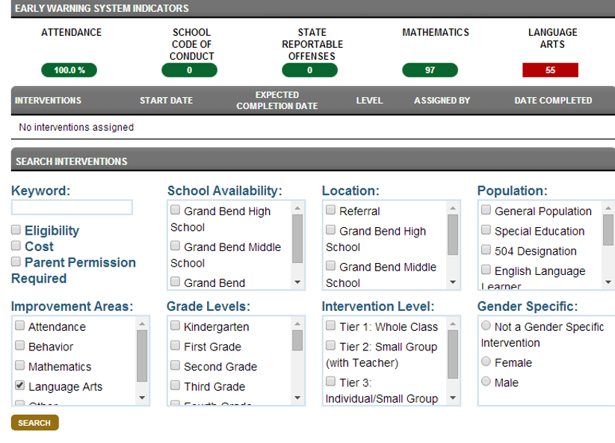
- Scroll to the intervention you want to assign and select Assign Intervention | 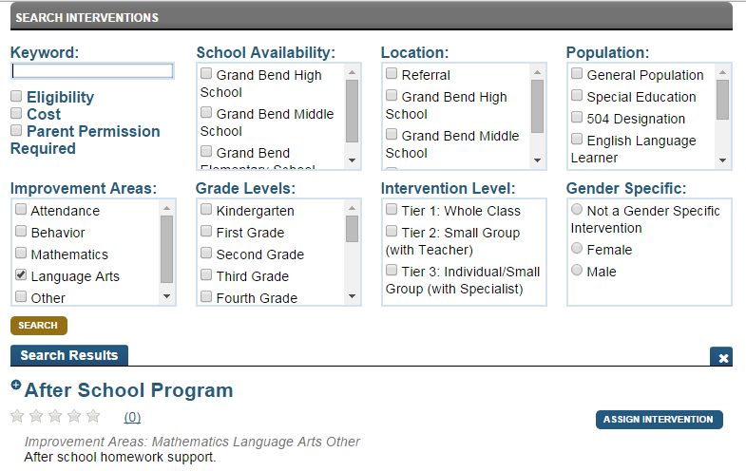
Add Intervention to the catalog:  - Go to the Interventions tab in the Dashboard  - Click Add Intervention  - Fill in intervention details | 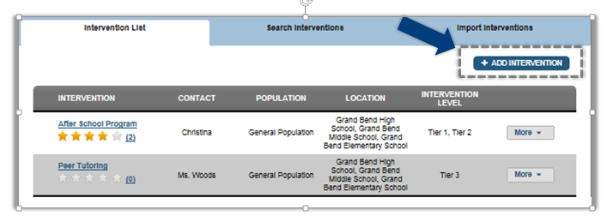
Edit existing Intervention details:  - Select the Intervention you wish to edit  - Select the More button from the menu  - Select Edit | 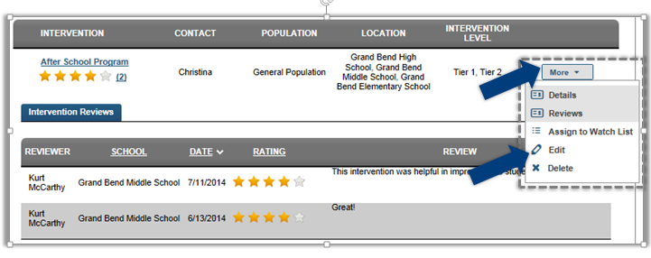
Delete Intervention from the catalog:  - Select the Intervention you wish to delete  - Select the More button from the menu  - Select Delete | 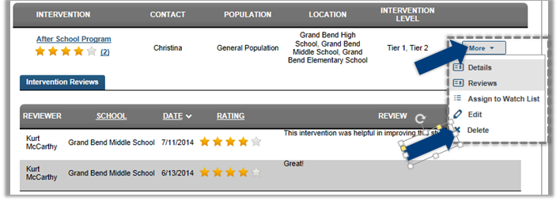
Import Interventions into the catalog:  - Select the Import Interventions tab, under Interventions  - Select a District from the drop down menu  - Select the Interventions you wish to import | 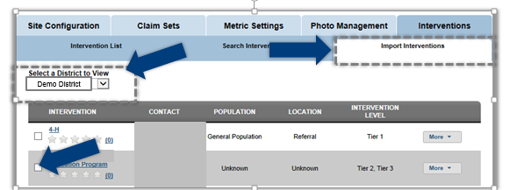
Assign an Intervention to a Watch List  - Select the intervention you wish to assign  - Click the More button  - Click Assign to Watch List | 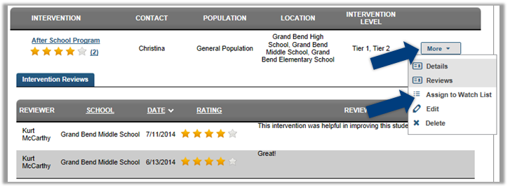
Enable intervention security  - Click the button in the Security column to change the status  - On the Edit security screen click the restricted button  - select staff members who can view or edit this intervention  - Click confirm | 