Math News

August 2023

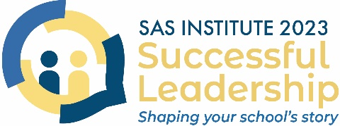
Join us at the SAS Institute 2023!
The Pennsylvania Department of Education's 2023 SAS Institute, Successful Leadership: Shaping Your School’s Story, is scheduled for December 11-13, 2023, at the Hershey Lodge and Convention Center.
PDE encourages educators to highlight programs and initiatives that address topics impacting our schools and students positively. To submit a proposal, access the proposal form at https://forms.gle/WQ93Rif7vCCdLgkc8 for a list of proposed topics and other relevant details.
Proposal submission deadline: August 14, 2023.

PETE&C is returning to Hershey…and they're looking for great session content!
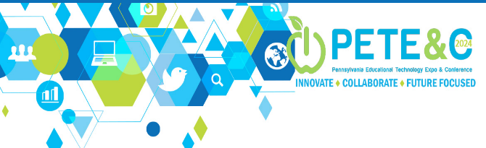
PETE&C presenters will have the unique opportunity and privilege to share their expertise with conference attendees. If you are interested in presenting, complete the Request For Proposal form by August 25, 2023.
PETE&C is proud to deliver 200+ educational sessions via multiple media sources − keynotes, breakout sessions, immersive experiences, playgrounds, poster sessions, networking events, and more − for LEAs across the state.

Math Coaching Endorsement Program

Penn State Harrisburg's Mathematics Coaching Endorsement program is the premier program dedicated to preparing grades K-12 educators to be leaders in their schools and promote mathematical instruction that targets the diverse learners in classrooms. The Math Coaching Endorsement Program is asynchronous so you can complete the modules at your own pace and convenience.

The four courses can be completed in a little more than one year. The fall 2023 course, EDMTH 442 Algebra and Functions Across the Curriculum, addresses the need to promote algebraic thinking and reasoning across grades K-8 and makes connections to algebra concepts at the secondary level.
The other courses include EDMTH 441 Geometry and Measurement Across the Curriculum (Fall 2024); EDMTH 443 Data Analysis and Probability Across the Curriculum (Spring 2024); and EDMTH 444 Numbers and Operations Across the Curriculum (Summer 2024).
Graduate credit applies. The courses can also apply to the Master of Education in Teaching and Curriculum.
For more information, contact Dr. Jane Wilburne (jmw41@psu.edu)

STEM EXPERIENCES

The StellarXplorers National Space Design Competition is a fun, hands-on competition that is inspiring our nation’s youth to explore education and careers in space, aviation, and other STEM disciplines. Through a series of online competition rounds, teams of students are challenged to solve real-world space missions focused on orbit planning, satellite design, and launch vehicle operations. This program engages students’ critical thinking, problem solving, teamwork, and leadership skills, while also giving them direct access to industry-grade training and software.

No prior experience is required for participation. All training is provided, and volunteer mentors are available to provide real-world expertise to teams.

To learn more about how to get involved, visit www.stellarxplorers.org/competition, or register to attend one of our upcoming 30-minute information sessions on Aug. 9 or Aug. 31. Session recordings will be shared with all registered attendees.

If you know school administrators or teachers that may be interested in bringing this program to their schools, kindly share this email with them. Our staff is happy to answer any questions at info@stellarxplorers.org.

What is BotsIQ?
BotsIQ is a workforce development program of the Pittsburgh Chapter National Tooling & Machining Foundation. It was created to provide a pathway for youth to explore rewarding careers in manufacturing.
Through exciting, hands-on, project-based learning opportunities, BotsIQ attracts smart, capable students who love to build things and solve problems – exactly the type of people that will comprise the future manufacturing workforce.
BotsIQ has three overarching goals:
- To advance STEM education
- To provide resources to local schools to develop hands-on technical learning
- To link students with industry mentors and promote an understanding of manufacturing and STEM career pathways
BotsIQ offers exciting, hands-on programs that connect students to in-demand manufacturing careers. All programs are aligned with industry’s needs and provide opportunities for students to partner with professionals in a variety of manufacturing and STEM careers.
- CALENDAR
- BOTSIQ ACADEMY
- HIGH SCHOOL COMBAT ROBOTICS
- COBOT CHALLLENGE
- CLOSE THE LOOP

The ButterBee’s
ButterBee's educational school programs "stem" from selfless generosity, allowing us to fund high quality programs for students at no cost to schools. Removing the barriers imposed by fees and expenses, allows students to bloom with the appreciation they gain for pollinators.
ButterBee Foundation's cross-curricular programs are developed by certified teachers to combine engagement with rigor and include developmentally appropriate material for students in grades K-12. Educators have access to a wide variety of engaging STEM lessons, meaningful activities for students, and fun virtual field trips carefully crafted to enhance the current classroom curriculum. Every lesson challenge students to apply academic skills to real-world problems. Let curiosity take the lead as learners of all ages explore the fascinating world of the mighty pollinators we rely on.

Technology Student Association (TSA)
The Technology Student Association (TSA) provides student members the opportunity to explore a wide variety of STEM (Science, Technology, Engineering, and Math) education and career-interest areas. All TSA middle school competitions and high school competitions are correlated with national STEL standards, directly aligned to the Pennsylvania Technology & Engineering components of the STEELS Standards, and can be integrated into and enhance STEM curriculum. Participation in TSA competitions allows TSA members to apply technology and engineering skills in challenging and innovative ways. Working individually or as a team, TSA members are motivated by the inspiration and enthusiasm gained from being recognized for the successful application of those skills. Affiliation for 2023-2024 will reopen on September 1, 2023. If you are in starting a PA-TSA chapter, please contact the Pennsylvania State TSA Advisor, Brandt Hutzel – brhutzel@pa.gov.

SAS PD Center: Explore Professional Learning Opportunities
The SAS PD Center has several new offerings to support your professional growth. Courses are self-paced, no cost, and provide Act 48 hours. Some sample course titles:
- Implementing the Standards for Mathematical Practice (Standards 1-4)
- Using PBS Learning Media in the Classroom
- Introduction to Structured Literacy
- Addressing Implicit and Explicit Bias in the Classroom
- Comprehensive Mental Health for Teachers
- Pathways to Graduation: Guiding Students in Decision Making
- Self-Awareness and Reflective Practices for Equitable Classrooms
- Trauma-Informed Programs
- Specially Designed Instruction for Gifted Learners

Content Advisor Contact Information
If you have any questions concerning Math News information, the Standards Aligned System (SAS), or information regarding Curriculum, Instruction or Assessment, please contact me at kmauro@pa.gov.
Kevin Mauro, Mathematics Curriculum Advisor

