Pennsylvania Depart of Education
The Standards Aligned System Portal (SAS)

Training provided by the Division of Instructional Quality:

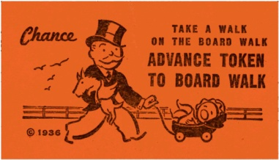
What do you hope to learn at this training?

Topic | √ Items that interest you | Information to remember | Next Steps
Homepage
Element | “Big Six”
Standards
Assessments
Topic | √ Items that interest you | Information to remember | Next Steps

Curriculum Framework
Instruction
Materials & Resources
Safe and Supportive Schools

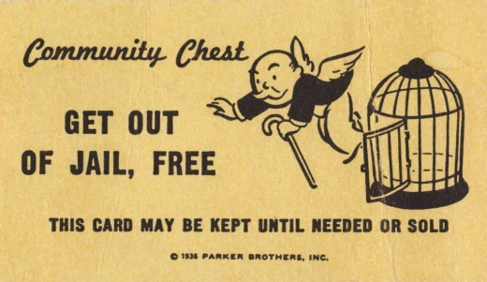
Identify something new that you learned during this part of the training.

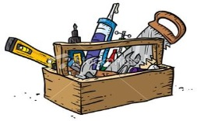
MySAS Toolkit
Tools/Parts | How do I use this tool? | Next Steps
Profile

ePortfolio

My Website

My Assessments

My Curriculum Maps

SLOs

My Lessons

Communities

PD Center

- Identify the tool that will be most useful to you as a teacher or school/curriculum leader.

- What are the qualities of the tool that make it useful?

