Math News

Summer 2021

PCTM 2021 Annual Summer Conference

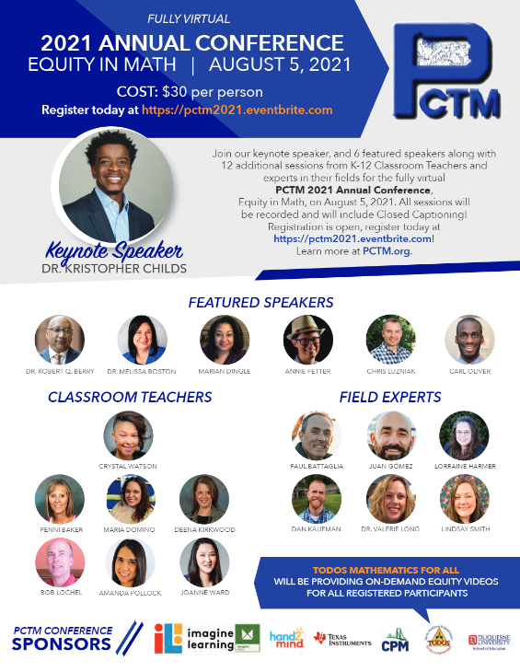

Plan to attend the PCTM 2021 Annual Summer Conference scheduled for Thursday, August 5, 2021.

This year’s theme is “Equity in Math”.

To register, click here: https://pctm2021.eventbrite.com
To view the flyer and to see ALL speakers, click here: PCTM Registration Flyer.

Evidence-based Resources

5 Evidence-Based Recommendations for Teaching Math to Young Children

Evidence-Based Specially Designed Instruction in Mathematics – Resource Guide

POWER Library Highlights
- E-Resources: E-Resources (subscription databases of articles, news, photographs, videos, DIY, etc.) will be particularly useful in lesson plans and for research resources. Access POWER Library E-Resources !
- Kids and Teens Sites: Sites designed for kids and teens are available at POWER Kids and POWER Teens !
- 24/7 Help: 24/7 live chat help! Text a Librarian and Email a librarian are available too.
- Single Sign-On: Remote access to POWER Library is available via Single Sign-On. Contact your school librarian or HSLC for more information.
- Lesson Plans! The POWER Library OER Hub, created to support PA educators is populated with lesson plans created specifically for POWER Library application; they are ready to download and remix. Visit the POWER Library OER Lesson Plans Hub !

To learn more, access POWER Library .

Additional Resources

PBS
Find engaging media and integrated activities designed for middle school students of diverse learning styles and backgrounds. Produced by a collaborative of public media stations and producers with funding from the Corporation for Public Broadcasting, access these resources at
https://witf.pbslearningmedia.org/collection/mathcore/?utm_source=email&utm_medium=&utm_content=&utm_campaign=

Patrick JMT
Patrick makes it super easy for anyone to learn math through a collection of useful video lessons. Patrick has been teaching math for 8 years at the university level. His website, Patrick JMT offers tone of free video tutorials covering a wide variety of mathematical topics that include Calculus, Arithmetic, Algebra, Trigonometry and many more. Use the search box in the website to search for specific math videos or you can scroll down and browse through the collection of videos in the homepage.

Game-Based Learning
In game play, the progress a player makes is through learning. This happens as students grasp and understand embedded knowledge and skills required to successfully navigate a new system. The challenge and the progress of understanding a new concept through gaming is what makes a game enjoyable.

Articles

The Math Behind the Perfect Free Throw | Innovation | Smithsonian Magazine

IES released a new report, 2012–2016 Program for International Student Assessment Young Adult Follow-up Study (PISA YAFS): How reading and mathematics performance at age 15 relate to literacy and numeracy skills and education, workforce, and life outcomes at age 19
New Report: How Reading and Mathematics Performance at Age 15 Relate to Life Outcomes at Age 19

Professional Development Opportunities

AIU Math & Science Collaborative has been running since 2016. They have spent this past year designing an entirely virtual synchronous option and it worked out extremely well. All of the AIU MSC offerings are available fully virtual synchronous. I also want to point out (as it is captured on the flyers) that both the K-2 and the 3-5 Institutes qualify as evidence-based strategies for mathematics on the PA Evidence Resource Center. This is particularly important for all CSI/ATSI Schools. All PD Institutes and courses can be found here: https://www.aiumsc.net//servicesnumbered

We live in a fast-paced, data-driven world, and students need the skills to navigate it successfully. Data are no longer just rows and columns on a spreadsheet or confined to the math and science classrooms. Data are present in every discipline influencing decisions and actions.

So what is data literacy?
It’s the ability to consume, interpret and understand data. It’s being comfortable and confident facing a tidal wave of information. At the core of data literacy are foundational skills we can put into action to navigate our daily lives and foster change in our community. No matter where you are on your data literacy journey, SAS creates free tools and resources, alongside our education partners, to help you find your way. See the new SAS® data literacy program (not the Standards Aligned System of PDE)

Content Advisor Contact Information
If you have any questions concerning Math News information, the Standards Aligned System (SAS), or information regarding Curriculum, Instruction or Assessment please contact me at kmauro@pa.gov.
Kevin Mauro, Mathematics Curriculum Advisor

