Math News

May 2021

PCTM 2021 Annual Summer Conference

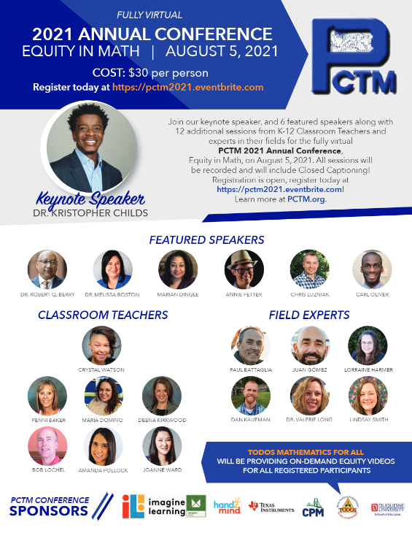

Plan to attend the PCTM 2021 Annual Summer Conference scheduled for Thursday, August 5, 2021.

This year’s theme is “Equity in Math”.

To register, click here: https://pctm2021.eventbrite.com
To view the flyer and to see ALL speakers, click here: PCTM Registration Flyer.

Evidence-based Resources
It may be a good time to review these evidence-based resources to support student achievement in math:

- Two short videos for families—one providing strategies for boosting middle schoolers’ math confidence and success and another on helping young children learn and love math
- Training materials to build teachers’ capacity to develop positive math mindsets—one set geared toward upper elementary and another for secondary school educators
- A blog post and video on stopping the spread of math anxiety in the elementary grades
- Activities and resources for parents and caregivers wanting to help develop young children’s math skills at home

POWER Library Highlights
- E-Resources: E-Resources (subscription databases of articles, news, photographs, videos, DIY, etc.) will be particularly useful in lesson plans and for research resources. Access POWER Library E-Resources !
- Kids and Teens Sites: Sites designed for kids and teens are available at POWER Kids and POWER Teens !
- 24/7 Help: 24/7 live chat help! Text a Librarian and Email a librarian is available too.
- Single Sign-On: Remote access to POWER Library is available via Single Sign-On. Contact your school librarian or HSLC for more information.
- Lesson Plans! The POWER Library OER Hub, created to support PA educators is populated with lesson plans created specifically for POWER Library application; they are ready to download and remix. Visit the POWER Library OER Lesson Plans Hub !

To learn more, access POWER Library .

Additional Resources

PBS
Find engaging media and integrated activities designed for middle school students of diverse learning styles and backgrounds. Produced by a collaborative of public media stations and producers with funding from the Corporation for Public Broadcasting, access these resources at
https://witf.pbslearningmedia.org/collection/mathcore/?utm_source=email&utm_medium=&utm_content=&utm_campaign=

Articles
Elementary students may struggle with the wording of problems, and the visual supports of comics can help them focus on the math.
How to Turn Math Word Problems Into Engaging Comics | Edutopia

Content Advisor Contact Information
If you have any questions concerning Math News information, the Standards Aligned System (SAS), or information regarding Curriculum, Instruction or Assessment please contact me at kmauro@pa.gov.
Kevin Mauro, Mathematics Curriculum Advisor

