Purpose: This will serve as a formative assessment of participants in the Assessment Literacy Course. Results of the assessment will be used to create a guide for instruction and content in the Assessment Literacy course. This will facilitate educator achievement in increasing rigor, reliability, and validity of assessments offered in each grade level.

Directions:
1. Based on your knowledge of item types, identify the positive and/or negatives of each question.
2. Fix the question if needed to meet the criteria for a well-constructed question.
3. Within your group discuss changes needed to assess student achievement at a different depth of knowledge level.

1. 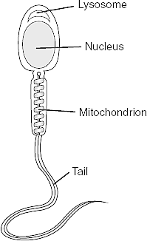 Which structure stores most of the genetic information?  A. mitochondrion  B. lysosome  C. nucleus  D. tail | construction positive/negatives-  changes-
2. “People were running toward him like iron filings to a magnet.”  The author uses this simile to emphasize that the people  A. were interested in the news about the gold  B. were curious about the hip’s arrival  C. wanted to become gold prospectors  D. were unable to resist reading about the gold | construction positive/negatives-  changes-
3. Which of the following is the best definition of seismograph?  A. an apparatus for measuring sound waves  B. an apparatus for measuring heat waves  C. an apparatus for measuring earthquake waves  D. An apparatus for measuring ocean waves | construction positive/negatives-  changes-
4.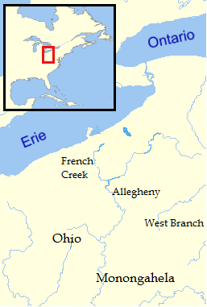 As an officer in the British Army in the 1750’s, use the map of the Ohio country mark where you would locate trading posts /forts to gain strategic control of the area for trade and defense. Provide a short explanation of your reasoning in the space below.  (Not to scale) | construction positive/negatives-  changes-
5 Kelly is chairperson on the cheerleader bake sale to raise funds for new uniforms which are $200 a piece for the 8 member squad. She has practice until 5 P.M. every night. She has Chemistry Lab 3 hours and 15 before she goes home. She had lunch 2 hours and 10 minutes before her Lab class. Lunch is the only time she has to meet with the members of the bake sale committee. What time should be on her e-vite to have the committee members meet her for lunch?  A. 10:25 PM  B. 10:25 AM  C. 11:35 PM  D. 11:35 AM | 5.  construction positive/negatives-  changes-
6. Based on the entire passage, what is the meaning of the word “momentous” in line 18?  A. Causes much happiness  B. Creates a great disturbance  C. Occurs simply by chance  D. B and C | construction positive/negatives-  changes
7. Sergei Prokofiev was commissioned to write a musical symphony for children. Each character in the story has a particular instrument and a musical theme to tell the story. Walt Disney produced an animated version of the work in 1946 with Sterling Holloway providing the voice of the narrator. This children’s classic is known as: ___________________.  A. Austin Powers Gold Member  B. Peter and the Wolf  C. Bugs Bunny 1001 Rabbit Tales  D. Sleeping Beauty | construction positive/negatives-  changes-
8. Evaluate the nutritional needs of a family of three with two adults and a preschool child. Choose recipes for a full day of meals and snacks to meet these needs. Please justify the menu choices, explaining the ways in which these choices are nutritionally sound and meet the daily requirements of nutritional needs by using the provided food pyramid.  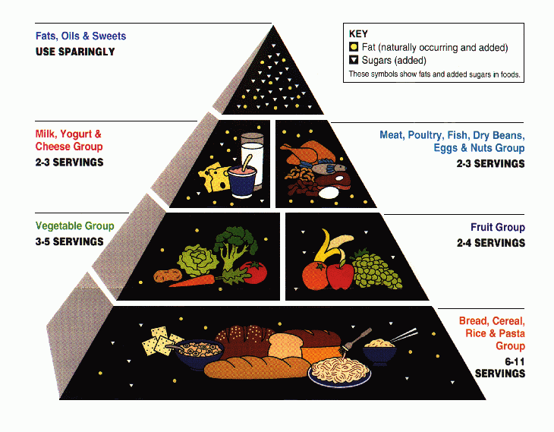 | construction positive/negatives-  changes-
9. In what year did the United States enter World War 1?  A. 1776  B. 1865  C. 1917  D. 1941 | construction positive/negatives-  changes-
10. Which of the following cell types is formed by meiosis?  A. muscle cells  B. sperm cells  C. skin cells  D. blood cells | construction positive/negatives-  changes-

