Purpose: This will serve as a formative assessment of participants in the Assessment Literacy Course. Results of the assessment will be used to create a guide for instruction and content in the Assessment Literacy course. This will facilitate educator achievement in increasing rigor, reliability, and validity of assessments offered in each grade level.

Directions: Based on your understanding of Webb’s Depth of Knowledge, assign the appropriate level to the following assessment questions.
Webb’s Depth of Knowledge

Level 1: Recall and Reproduction Level 3: Strategic Thinking
Level 2: Skills and Concepts Level 4: Extended Thinking

DOK
1. 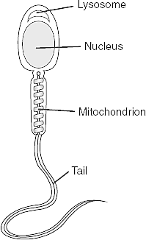 Which structure stores most of the genetic information?
A. mitochondrion
B. lysosome
C. nucleus
D. tail

2. “People were running toward him like iron filings to a magnet.”
The author uses this simile to emphasize that the people
A. were interested in the news about the gold
B. were curious about the ship’s arrival
C. wanted to become gold prospectors
D. were unable to resist reading about the gold

3. Which of the following is the best definition of seismograph?
A. an apparatus for measuring sound waves
B. an apparatus for measuring heat waves
C. an apparatus for measuring earthquake waves
D. an apparatus for measuring ocean waves

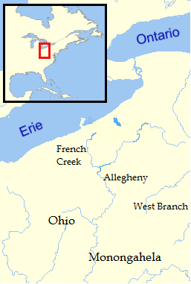4. As an officer in the Royal British Army in the 1750’s, use the map of the Ohio country to mark where you would locate trading posts /forts to gain strategic control of the area for trade and defense. Provide a short explanation of your reasoning in the space below.
(Not to scale)

5 Kelly is chairperson on the cheerleader bake sale to raise funds for new uniforms which are $200 a piece for the 8 member squad. She has practice until 5 P.M. every night. She has Chemistry Lab 3 hours and 15 minutes before she goes home. She had lunch 2 hours and 10 minutes before her Lab class. Lunch is the only time she has to meet with the members of the bake sale committee. What time should be on her e-vite to have the committee members meet her for lunch?
A. 10:25 PM
B. 10:25 AM
C. 11:35 PM
D. 11:35 AM

6. Based on the entire passage, what is the meaning of the word “momentous” in line 18?
A. Causes much happiness
B. Creates a great disturbance
C. Occurs simply by chance
D. B and C

7. Sergei Prokofiev was commissioned to write a musical symphony for children. Each character in the story has a particular instrument and a musical theme to tell the story. Walt Disney produced an animated version of the work in 1946 with Sterling Holloway providing the voice of the narrator. This children’s classic is known as: ___________________.

A. Austin Powers Gold Member
B. Peter and the Wolf
C. Bugs Bunny 1001 Rabbit Tales
D. Sleeping Beauty

8. Evaluate the nutritional needs of a family of three (two adults and a preschool child). Choose recipes for a full day of meals and snacks to meet these needs. Please justify the menu choices, explaining the ways in which these choices are nutritionally sound and meet the daily requirements of nutritional needs by using the provided food pyramid.

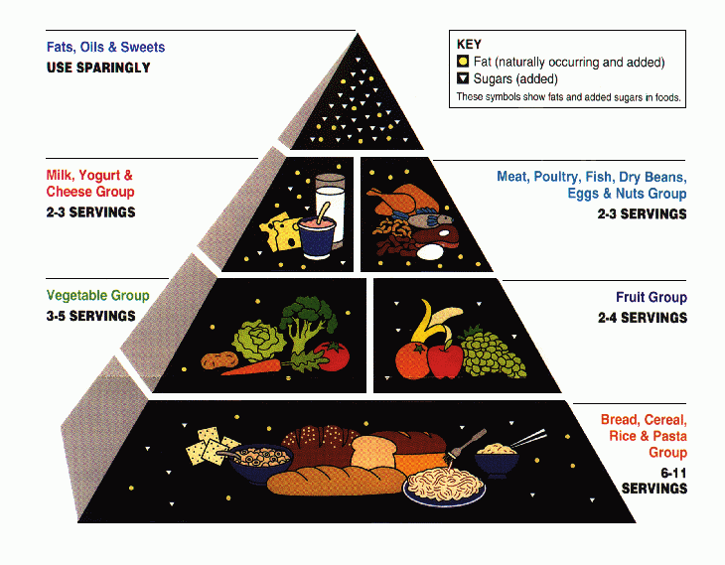

9. In what year did the United States enter World War 1?
A. 1776
B. 1865
C. 1917
D. 1941

10. Which of the following cell types is formed by meiosis?
A. muscle cells
B. sperm cells
C. skin cells
D. blood cells

