Grade 3:
Some friends are having a picnic at a park.
They take 5 cars to the park.
There are 4 people in each car.
Each person will eat 2 sandwiches at the picnic.
How many sandwiches in total will the friends eat at the picnic?
A. 11
B. 20
C. 22
D. 40

Grade 4:
There are 49,528 people living in a city. What is the value of the 4 in the number of people living in the city?
A. two times the two in the tens place
B. twenty times the two in the tens place
C. two hundred times the two in the tens place
D. two thousand times the two in the tens place

Grade 5:
Jake measured the amount of salt in two liters of seawater. His results are listed below.
first liter: 33.165 grams
second liter: 35.787 grams
He rounds both values to the nearest hundredth and adds them. What is the sum of the rounded amounts of salt Jake found in the seawater?
A. 68.95 grams
B. 68.952 grams
C. 68.957 grams
D. 68.96 grams

Grade 6:
Gary saves $2.50 each day. Which equation describes the relationship between the number of
days (d) Gary saves money and the total amount of money (m), in dollars, that he saves?
A. m = 2.50d
B. m = d – 2.50
C. d = 2.50m
D. d = 2.50/m
Grade 7:
Nadia is selling tickets for a school event. She has already sold 17 tickets. Her goal is to sell at
least 100 tickets. Each day she is able to sell up to 10 tickets. What is the minimum number of
days Nadia will need to sell tickets to reach her goal?
A. 5
B. 6
C. 8
D. 9
Grade 8:
1. The number of tickets sold for events at a theater last year varied with the cost per ticket, as shown in the scatter plot below.
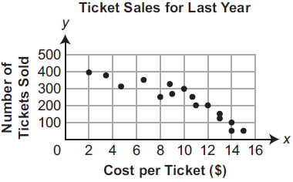
Based on the equation of the line of best fit for the scatter plot, which statement about the relationship between cost per ticket and number of tickets sold is true?
(A) The slope of the line of best fit is approximately –26.5, which means that for every $2 increase in cost per ticket, the number of tickets sold decreased by 26.5.
(B) The slope of the line of best fit is approximately –26.5, which means that for every $1 increase in cost per ticket, the number of tickets sold decreased by 26.5.
(C) The slope of the line of best fit is approximately 26.5, which means that for every $2 increase in cost per ticket, the number of tickets sold increased by 26.5.
(D) The slope of the line of best fit is approximately 26.5, which means that for every $1 increase in cost per ticket, the number of tickets sold increased by 26.5.

