Pennsylvania Department of Education
Course 7 Data Quality Check
Guided Practice Activities
Document #C7.3
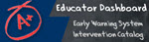

Guided Activities
Guided Activity #1: Data Quality Check
TASK: Use the Guided Activity handouts to help with this activity. Follow the instructions to complete the suggested activities and provide feedback on the form provided.
Only complete the activities pertinent to your role in the district and the Dashboard implementation.
On the feedback form, be as specific as possible if you encounter data issues. This will help the Dashboard Administrator resolve the possible issues as quickly as possible.

Login Instructions for all Roles
- To log in to the dashboard for your district, visit http://www.education.state.pa.us. Click Log In if you are already registered with the portal. If you are not registered, please click on “Register” to create a new account.

- Enter your username and password and click Log In.
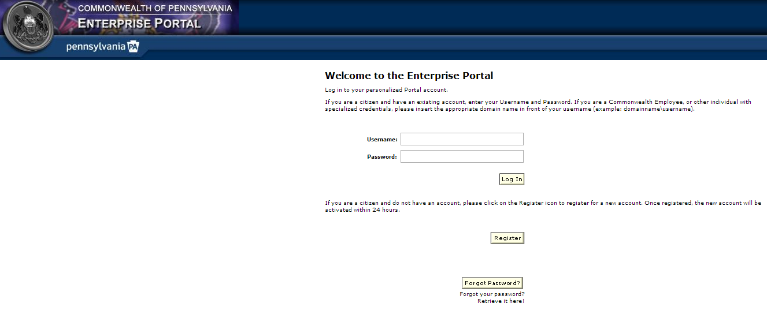

- Click My PDE on the Left Blue Pane to access the applications that you are authorized to view.
- Click on Testing, if you have NOT moved your Dashboard data to Production.
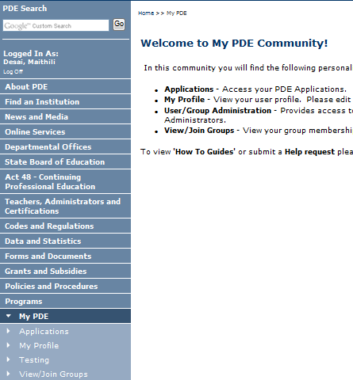
- Click on Dashboard under Insider PDE, if you have moved your Dashboard data to Production.
- Enter your PPID, DOB and the last four digits of your SSN and click Sign In.
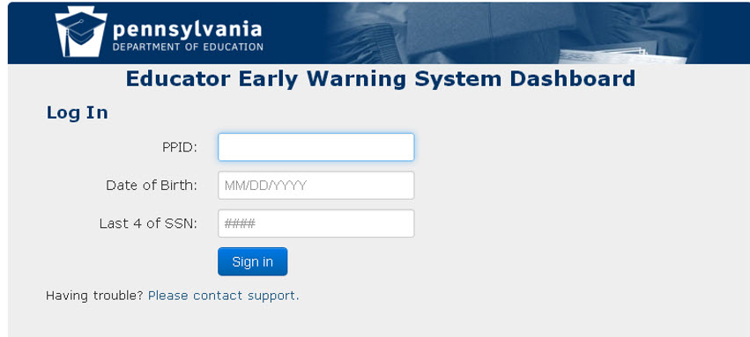

Administrator Data Quality Check
Script #1 – Attendance Metrics
Steps to Execute:
- Login to the Dashboard – refer to the login instructions above.
- Click on the School Information tab. This will direct you to your school’s Information page.

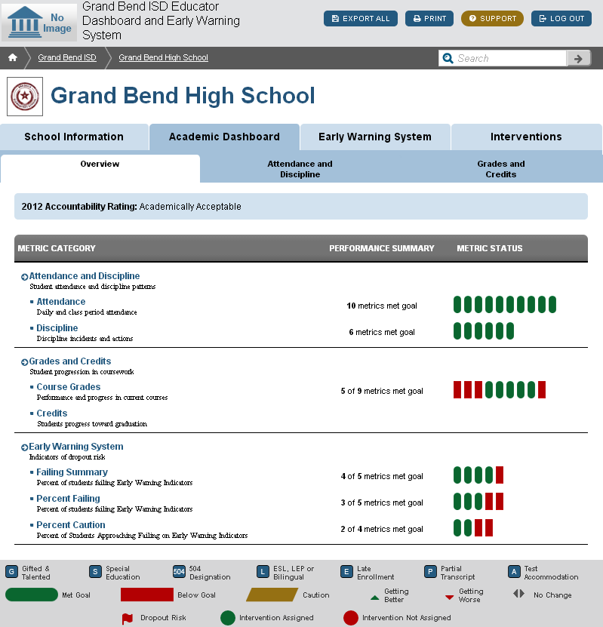

- Click on the “Students by Grade” sub-tab.
  - Select a student from the list.

- Alternatively, if you know the name or unique ID number of the student you would like to check, you can enter it into the Search bar.
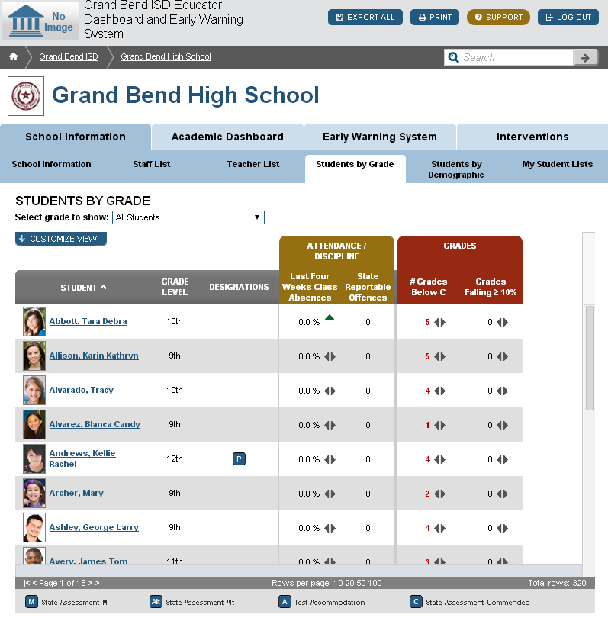

- Click on the student’s “Attendance and Discipline” sub-tab. This page contains metrics showing the student’s attendance data.
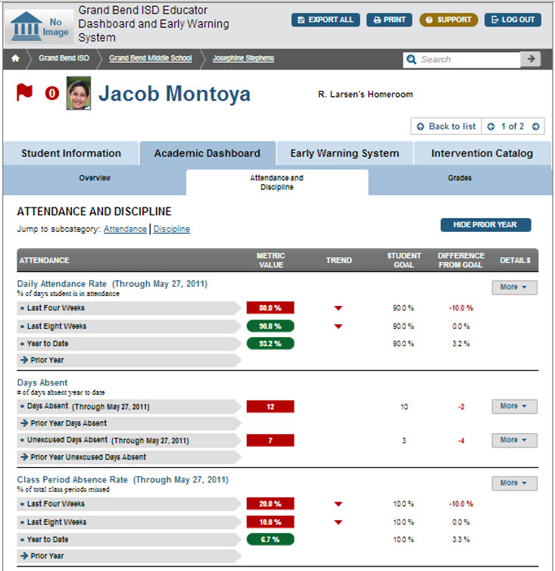

- Verify that the student has data for all attendance metrics on the page. Verify that the student’s attendance data matches the student’s data in the district’s Student Information System.
  - Note: Prior Year metric data will not contain data when the Dashboard is initially launched.

- Verify that the Days Absent “Absences by Grading Period” drilldown includes excused and unexcused data by grading period.
- Repeat for 2-3 students across several grade levels.

Script #2 – Discipline Metrics
Steps to Execute:
- Login to the Dashboard – refer to the login instructions above.
- Click on the School Information tab. This will direct you to your school’s Information page.

- Click on the “Students by Grade” sub-tab.
  - Select a student from the list.

- Alternatively, if you know the name or unique ID number of the student you would like to check, you can enter it into the Search bar.

- Click on the student’s “Attendance and Discipline” sub-tab. This page contains metrics showing the student’s discipline data.

- Verify that the student has data for all discipline metrics on the page. Verify that the student’s discipline data matches the student’s data in the district’s Student Information System.
  - Note: Prior Year metric data will not contain data when the Dashboard is initially launched.

- Verify that the Discipline Referrals “Incidents Log” drilldown includes descriptions for discipline incidents.
- Repeat for 2-3 additional students across several grade levels.

Intervention Catalog Coordinator Data Quality Check
Script #1 – Adding an Intervention
Steps to Execute:
- Login to the Dashboard – refer to the login instructions above
- Click on the Interventions tab – the system will direct you to the page with the list of interventions in the district.
  - Note that for different Dashboard roles the home page may look different.
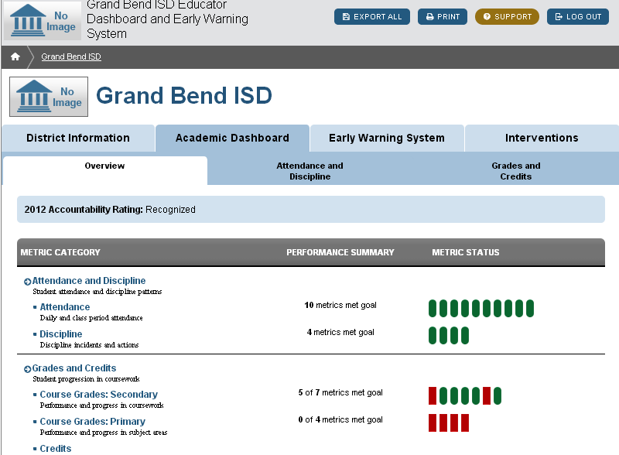

- Click on Add Intervention above the intervention list – the system will direct you to a page where you can enter information about a new intervention.
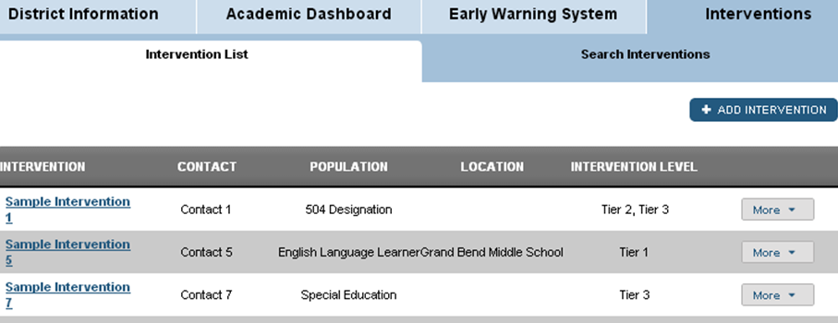
- Enter the required values for an intervention.
- Click Add Intervention – the system will direct you back to the intervention list page.
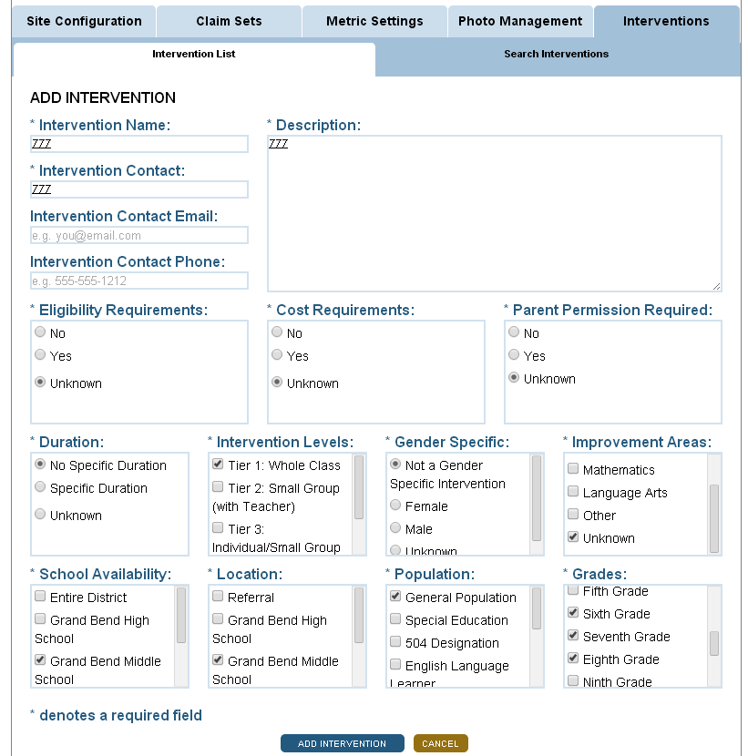

- Look in the intervention list for the title of the intervention you just entered.
  - Click on the name of the intervention – it should expand to show the details
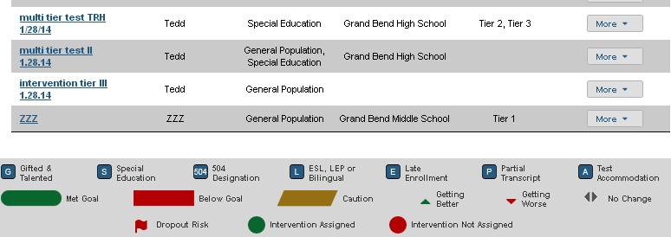
- Compare the details shown to the ones you entered to ensure they are the same.
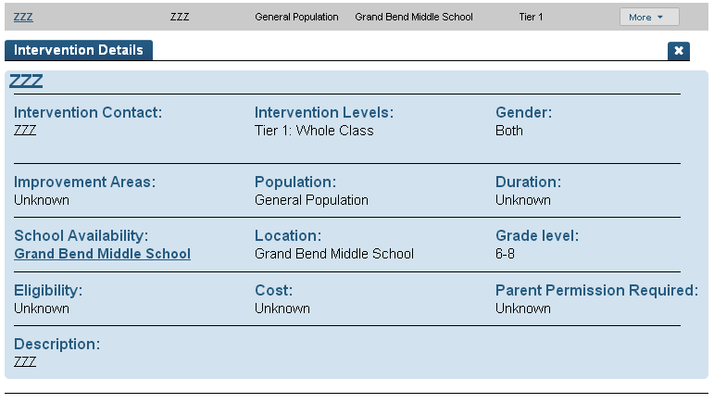
6

Script #2 – Editing an Intervention
Steps to Execute:
- Login to the Dashboard – refer to the login instructions.

- Click on the “Interventions” tab. This will take you to the district’s Intervention Catalog

- Identify an intervention that you wish to edit. For the purposes of this activity, select the intervention that you just created.

- Click on the “More” menu for that intervention.

- Click on the edit icon.

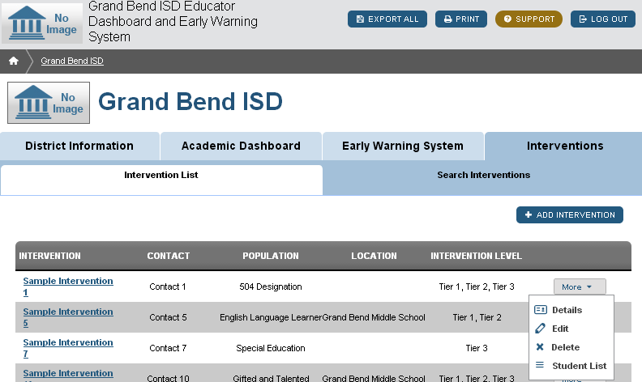

- This will take you to the “Edit Intervention” page.
  - Make the desired edits for this intervention.
  - Click “Save Intervention” when you are finished.

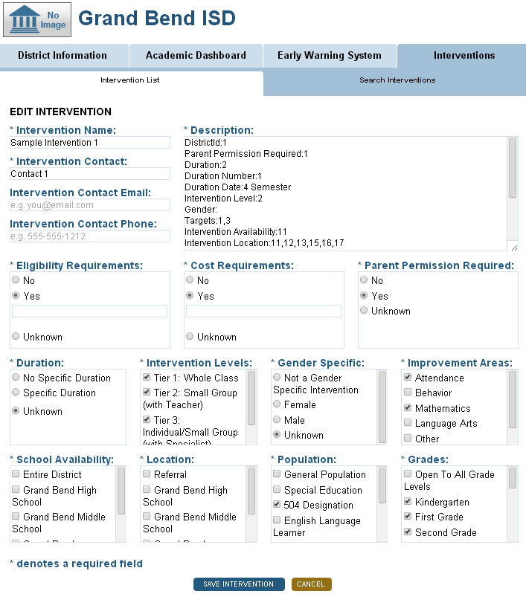

- Review the intervention you just edited to verify the changes were saved.

Script #3 – Deleting an Intervention
Steps to Execute:
- Login to the Dashboard – refer to the login instructions above.

- Click on the “Interventions” tab. This will take you to the district’s Intervention Catalog.

- Identify an intervention that you wish to delete. For the purpose of this activity, delete the intervention that you just created.

- Click on the “More” menu for that intervention.

- Click on the delete icon.
  - Please note, deleting an intervention from the catalog will not remove the intervention from any students. The intervention name will be updated to “Deleted: Name” to show this intervention is no longer available to assign to other students.

- This will display the “Delete Intervention” pop-up box. Click “Confirm.”

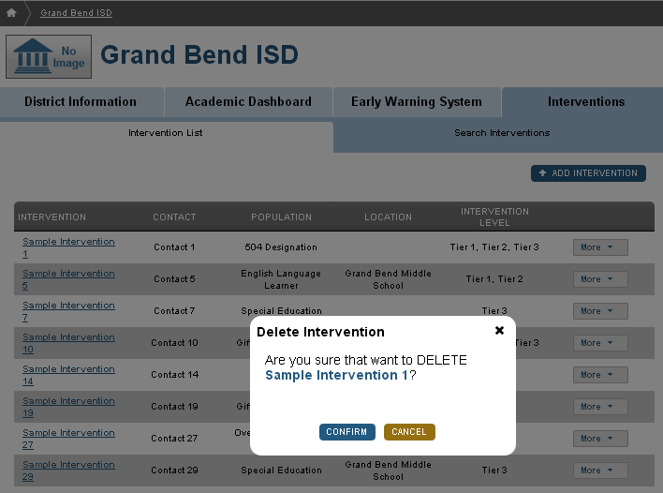

- Review the Intervention list to verify the intervention you just removed does not show up.

Staff Data Quality Check
Script #1 – Confirming Sections
Steps to Execute:
- Login to the Dashboard – refer to the login instructions above.
- Click on the “Student List” dropdown menu – The menu will list all of your current sections. Confirm that all of your current sections are listed in the dropdown and that they are your sections.
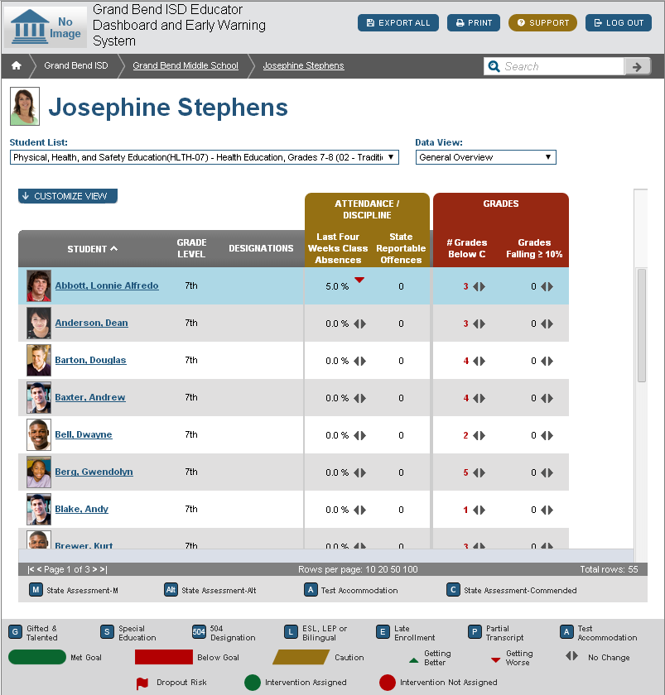

- A list will appear with all of the students who are in that section. Click on a section.
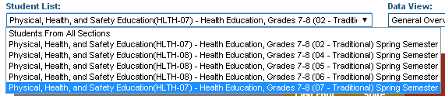
- Check the list against your records to confirm that the students listed are your students and are in that section.
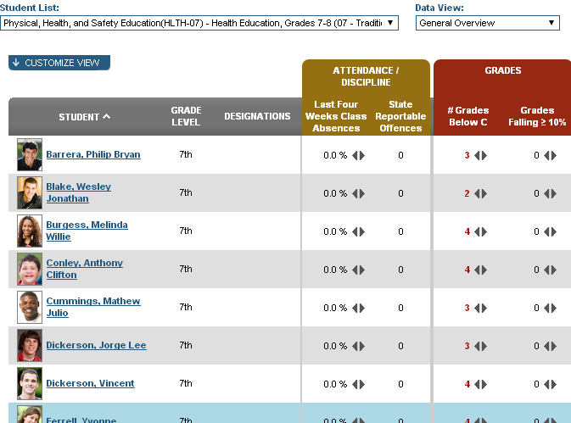
- Repeat steps 2-4 to review student data across several sections.

Script #2 – Grade Metrics
Steps to Execute:
- Login to the Dashboard – refer to the login instructions above.

- Click on the “Student List” dropdown menu – The menu will list all of your current sections. Click on one of your sections listed in the dropdown menu.

- Click on the name of a student in your student list. This will take you to the Overview page of the student’s Academic Dashboard.

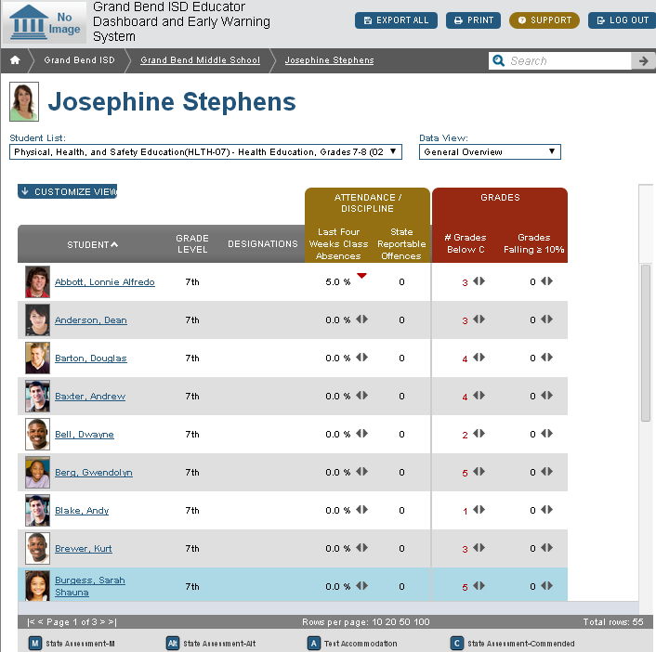

- Click on the student’s “Grades” sub-tab. This page contains metrics showing the student’s attendance and discipline data.

- Click on the “Class Grades” More menu. Click on the “Current Courses” drilldown.

- For the Class Grades metrics, verify that the denominator matches the number of courses listed in the most recent grading period in the student’s Class Grades Current Courses drilldown. Please note that the current course list is displayed as Fall then Spring.

- Verify that the numerator in the Failing metric matches the number of failing grades in the student’s “Current Courses” drilldown.

- Verify that the metric value of the Grades Below C metric matches the number of grades below C in the student’s “Current Courses” drilldown.

- Repeat this process for 2-3 students across several sections.

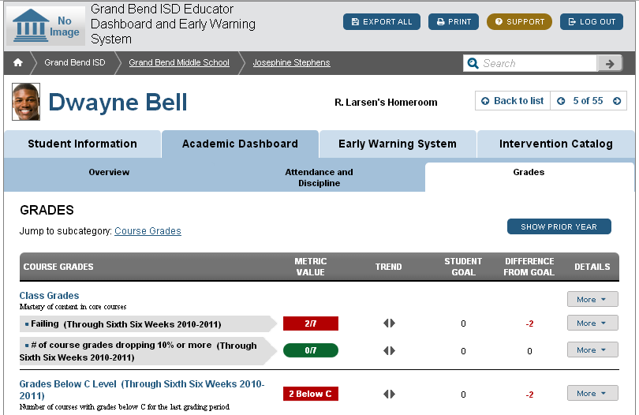
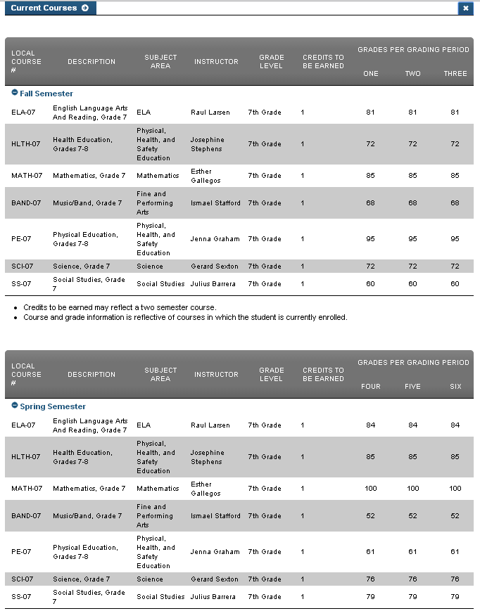

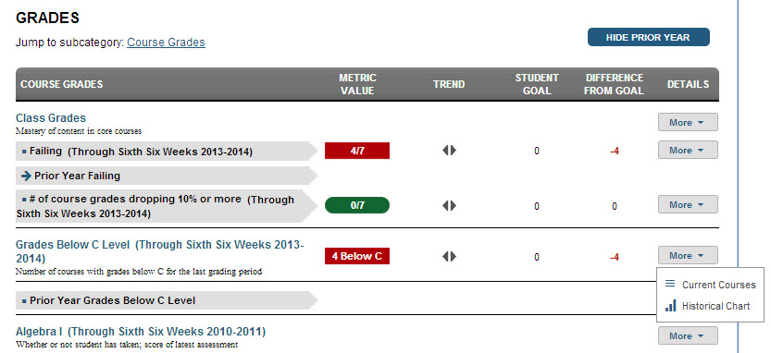

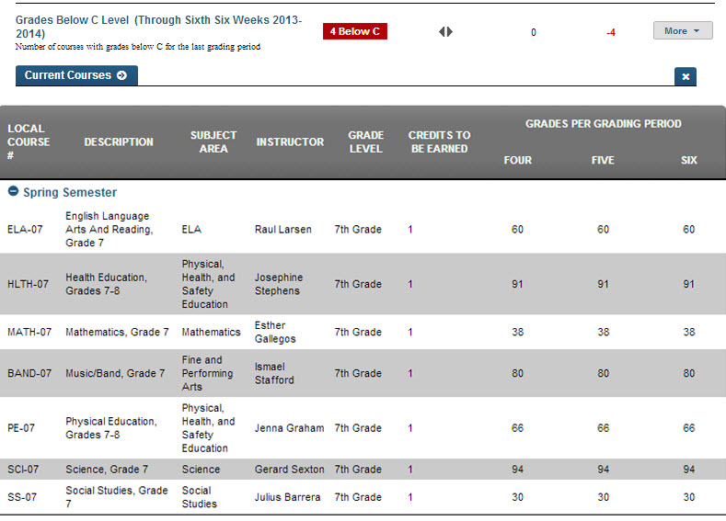

Data Quality Feedback Form
Instructions: Fill out the form below with each of the Data Quality Checks you complete. Try to be as specific as possible about the details of the data issue in order to facilitate a more speedy resolution.
My Name:
My Role:
Is the data issue affecting | a single student? | Y N
 | an entire section? | Y N
 | an entire demographic group? | Y N
Describe the data issue (including what Dashboard Tab you are viewing):

