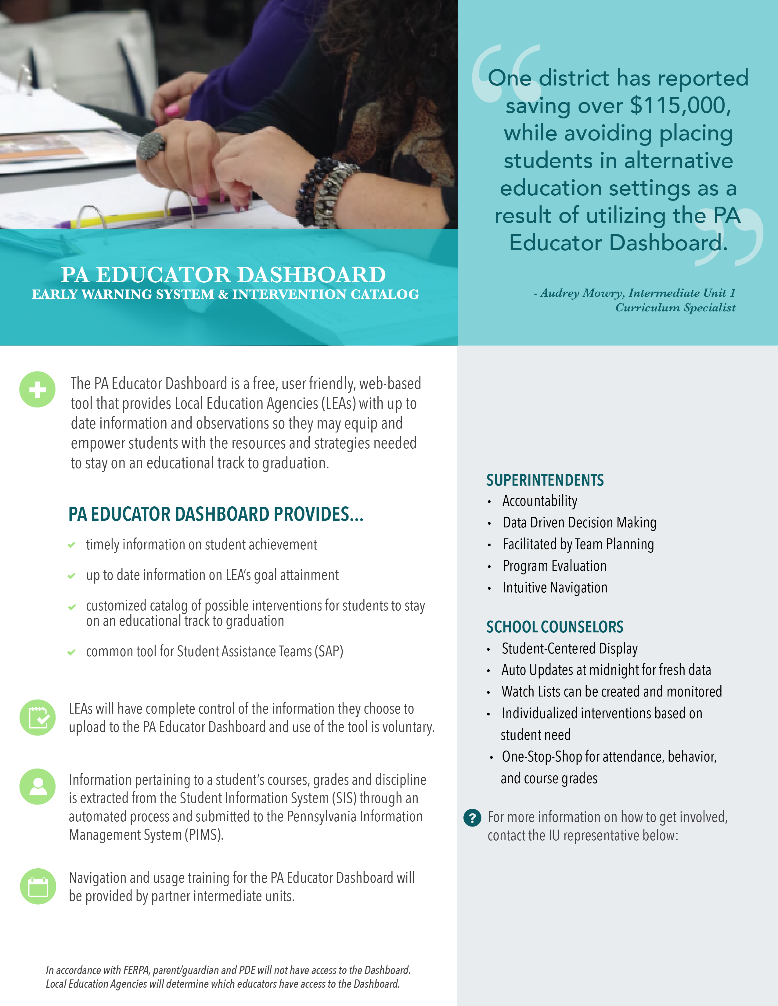

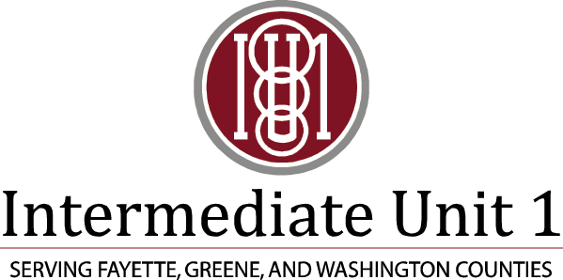

Audrey Mowry, Intermediate Unit #1

audrey.mowry@iu1.org

724-938-3241 x261

Intermediate Unit 1 is partnering with IUs across Pennsylvania to offer professional development on the free PA Educator Dashboard Early Warning System and Intervention Catalog.