|  |  |  |
| --- | --- | --- |
| Date | Topics | Pages |
| 8/29/16 | outlines concepts of point, line, plane, ray, segment.  Definitions of congruent, midpoint, and bisector of segment | 1 |
|  |  |  |
|  |  |  |
|  |  |  |
|  |  |  |
|  |  |  |
|  |  |  |
|  |  |  |
|  |  |  |
|  |  |  |
|  |  |  |
|  |  |  |
|  |  |  |
|  |  |  |
|  |  |  |
|  |  |  |
|  |  |  |
|  |  |  |
|  |  |  |
|  |  |  |
|  |  |  |
|  |  |  |
|  |  |  |
|  |  |  |
|  |  |  |

|  |  |  |
| --- | --- | --- |
|  |  |  |
|  |  |  |
|  |  |  |
|  |  |  |
|  |  |  |
|  |  |  |
|  |  |  |
|  |  |  |
|  |  |  |
|  |  |  |
|  |  |  |
|  |  |  |
|  |  |  |
|  |  |  |
|  |  |  |
|  |  |  |
|  |  |  |
|  |  |  |
|  |  |  |
|  |  |  |
|  |  |  |
|  |  |  |
|  |  |  |
|  |  |  |
|  |  |  |
|  |  |  |

Page 0

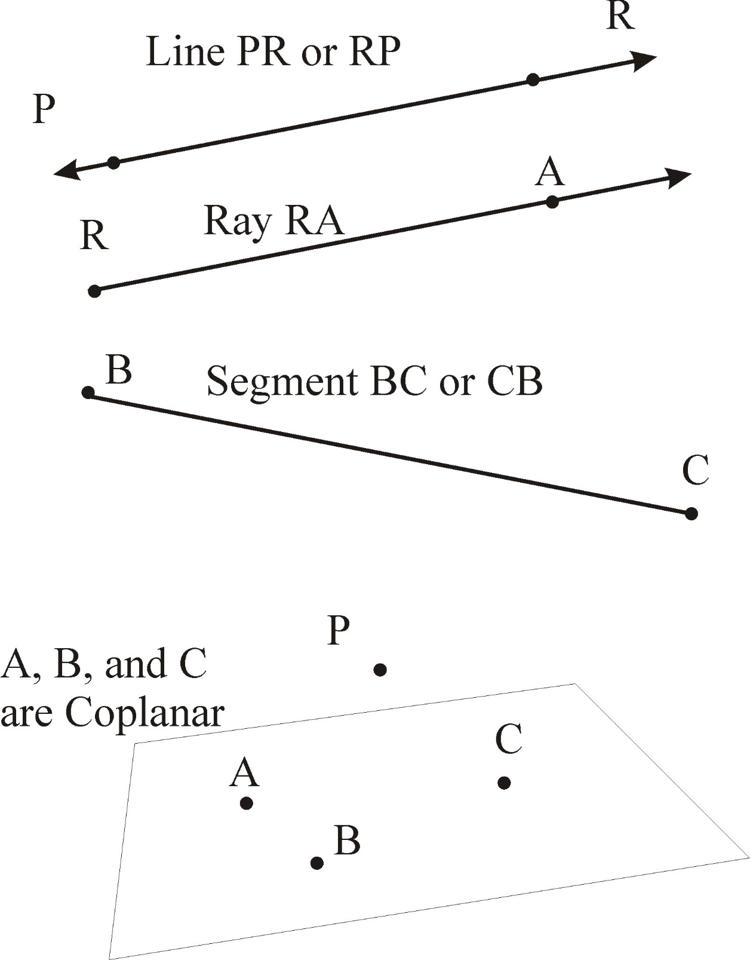 AB Bisects PQ at F



Chapter 1 – Points, Lines, Planes, and Angles Page 1

|  |  |
| --- | --- |
| Topics, Defs, Vocab  Undefined Terms  Point  Line  Collinear vs  non-collinear points  Plane  Coplanar vs  non-coplanar points  Intersection  Segment  Ray  Length  **Ruler Postulate**  **Segment Addition Postulate**  **Congruent**  Congruent Segments  **Midpoint of a Segment**  **Bisector of a Segment** | Details |
| **Not Strictly defined. Terms used by common understanding.** |
| **Like an address. Named with capital letters. Represented by a Dot** |
|  |
| **Named using two points on the line. PR or a lowercase letter.**  **A line has no ends. Order does not matter: PR and RP are the same line.** |
| **Collinear points are in the same straight line. Non-collinear points are not.** |
|  |
| **Named using a Capital letter (often in script) OR with three non-collinear points, Ex. Plane ABC** |
|  |
| **Coplanar points are all in some plane. Non-coplanar points are not.** |
|  |
| **Points that are in two figures.** |
|  |
| **A line segment includes two endpoints and all the pointe between them. BC** |
|  |
| **Ray – piece of a line with a starting point on one end.**  **Start naming from the endpoint. RA is not the same ray as AR** |
| **Opposite Rays have the same endpoint. Together a ray and its opposite = a line** |
|  |
| **In terms of a number line where every point is paired with a number: Length is the positive difference between the coordinates. (Always Positive)** |
|  |
| **Distance between any two points equals the absolute value of the difference of their coordinates** |
|  |
| **If B is between A and C on a line, then AB + BC = AC** |
|  |
| **Two objects that have the same size and shape are Congruent ≅** |
| **Segments that have equal length. AB ≅ CD if they are the same length.** |
|  |
| **The point that divides a segment into two congruent segments.** |
| **A Line, Segment, Ray, or Plane that intersects a segment at its midpoint.** |
|  |
| Summary Mostly outlines concepts of point, line, plane, ray, segment.  Definitions of congruent, midpoint, and bisector of segment. | |

Page 2



Angle Addition Postulate: 

Protractor

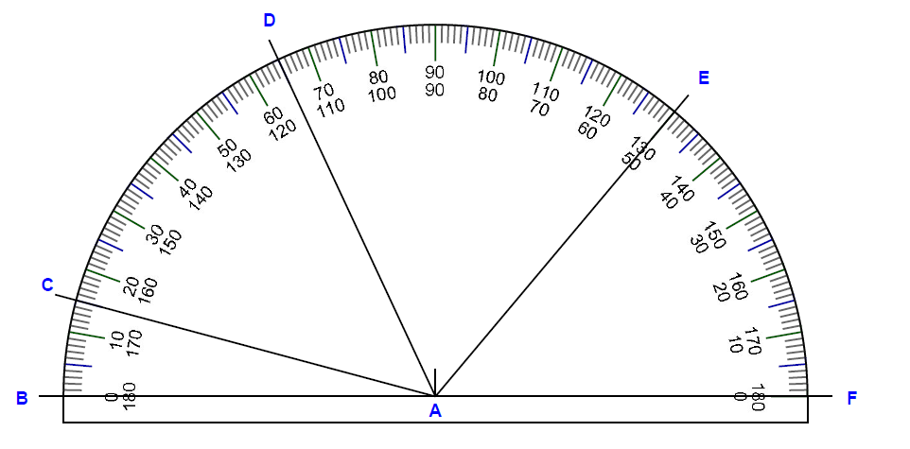

Chapter 1 – Reasoning in Geometry Page 3

|  |  |
| --- | --- |
|  | Details  ∠ ≅ ∆ ⦛⦜⦝⦟ |
| Angles | Denoted ∠ Formed by 2 rays 🡪 The rays are the “sides”, they meet at the vertex, the common endpoint. Named by three letters (vertex in the middle) |
| Types of Angles | Acute < 90°, Right = 90°, Obtuse between 90° and 180°, Straight = 180° |
|  |  |
| **Angle Addition Postulate** | If Point B lies in the interior of ∠AOC,  then m∠AOB + m∠BOC = m∠ AOC |
|  | If ∠ AOC is a straight angle and B is any point not on AC then  m ∠ AOB +m∠ BOC = 180 |
|  |  |
| Protractor | If you can line up one side of the angle with the “0” line on the protractor, you can read the angle on the scale. (Small angle 🡪 small guide number) OR  Line up the vertex at the center and subtract the two readings. |
|  | See example protractor: ∠FAE (50) ∠FAD (115), ∠EAD = 115-50 = 65° |
| **Protractor Postulate** | For every angle A, there corresponds a positive real number 0<m∠A≤180° |
|  |  |
| Congruent Angle | Congruent (≅) angles have the same measure (=).  Congruent is the term we use when comparing actual physical things.  Equal is the term we use when comparing the measurements (numbers). |
|  |  |
| Adjacent Angles | Adjacent Angles: Common vertex + Share one side + No common interior points |
| Angle Bisector | An angle bisector divides an angle into two angles of equal measure (congruent) |
|  |  |
| ! ! ! | We ONLY know what we are explicitly GIVEN. We cannot assume. |
| Markings | Tick Marks for congruent segments. Square at vertex for right angle.  Matching arc marks for congruent angles. |
|  |  |
| Definitions | Exist: there is at least one. Unique: there is no more than one  One and Only One: exactly one; shows existence and uniqueness |
| Postulate | Basic assumption accepted without Proof |
| Postulate 5  Postulate 6  Postulate 7  Postulate 8  Postulate 9 | - A line contains at least 2 points.  - A plane contains at least 3 points not all in the same straight line  - Space contains at least 4 points not all in the same plane.  Through 2 points there is exactly one line.  Through any three points there is at least one plane, and through any three *non-collinear* points, there is exactly one plane.  If two points are in a plane, then the line that contains the points is in that plane.  Two planes intersect in a line |
|  | |
|  | |
|  | |
|  | |
|  | |